1. 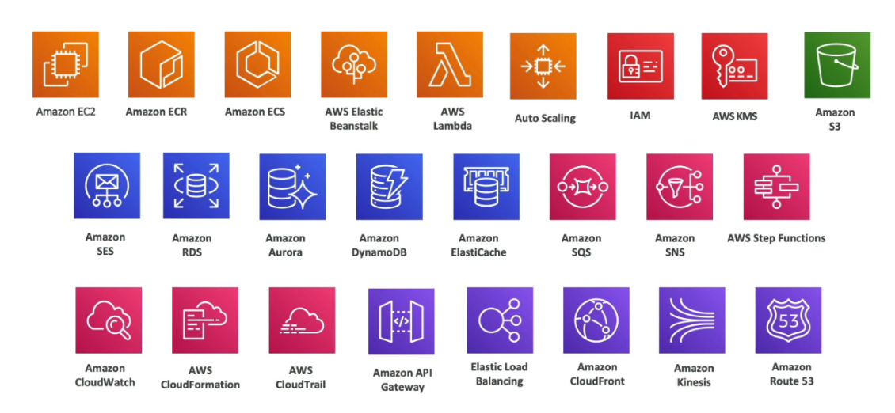**What we will learn in this course**
2. **AWS Cloud Overview**

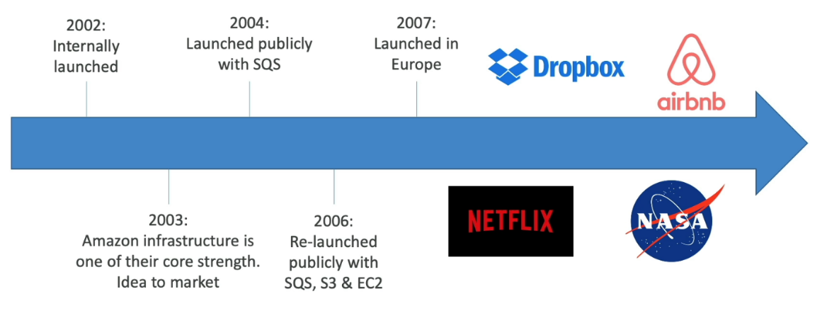**AWS Cloud History**

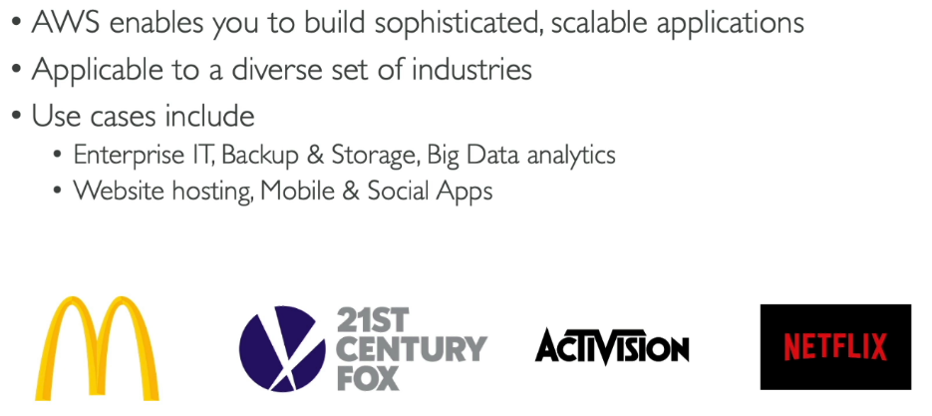**AWS Cloud Use cases**

**AWS Global Infrastructure**

AWS Global Infrastructure is the backbone of AWS services, designed for scalability, security, and fault tolerance. It consists of Regions, Availability Zones, Data Centers, and Edge Locations to ensure low latency, high availability, and compliance with local regulations.

**AWS Region**

An AWS Region is a geographic location with multiple isolated Availability Zones, providing independence and compliance with local laws. For example, **us-east-1 (North Virginia)** serves North America, while **ap-south-1 (Mumbai)** caters to South Asia. Regions allow users to deploy applications close to their customers for reduced latency.

**AWS Availability Zones (AZs)**

AZs are isolated clusters of data centers within a Region, connected by low-latency networks. Each AZ is physically separated to mitigate risks like power outages. For instance, the **us-east-1 Region** has six AZs (e.g., us-east-1a, us-east-1b), enabling applications to remain highly available during failures.

**AWS Data Centers**

AWS Data Centers are secure, state-of-the-art facilities housing the hardware for AWS services. They ensure redundancy through power backups and cooling systems, supporting infrastructure like EC2 and S3. Multiple data centers within AZs enhance reliability and allow seamless scaling.

**AWS Edge Locations/Points Of Presence (Pops)**

Edge Locations, also known as Points of Presence, are globally distributed sites that cache content via services like CloudFront, ensuring low latency for users. For example, streaming a video from **CloudFront's Edge Location in Kathmandu** provides faster delivery to nearby users compared to accessing the data directly from an AWS Region.

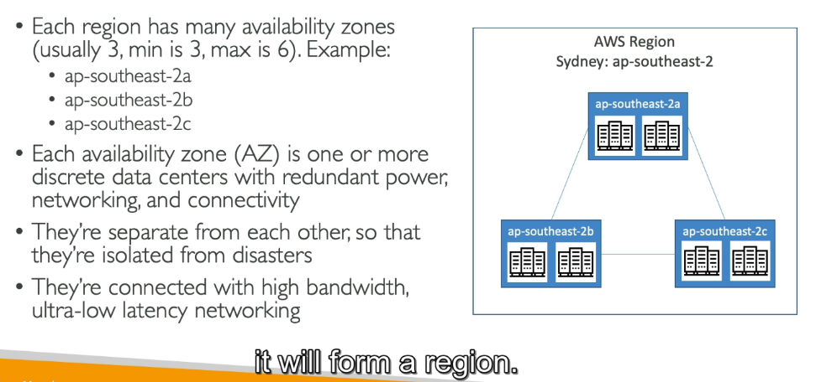It helps deliver content, such as websites, videos, or files, much faster by caching it closer to the user rather than retrieving it from the main AWS Region.

**How to choose an AWS Region**

Compliance with data governance and legal requirements : Data never leaves a region without your explicit permission.

Proximity to customers: Reduced Latency

Available services within a region: New services and new features aren’t available in every region

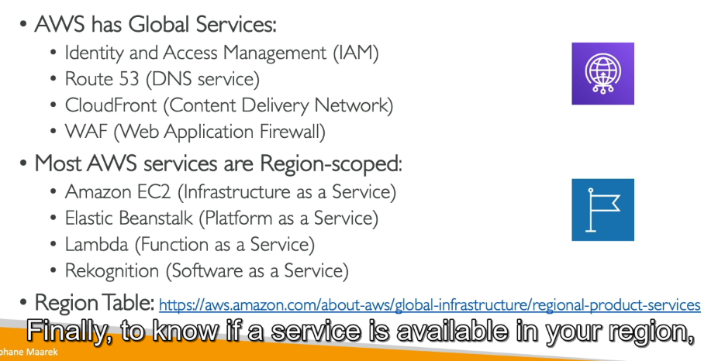Pricing: pricing varies region to region and is transparent in the service pricing range

1. **IAM: Users & Groups**

IAM= Identity and Access Management, Global Service

Here we are going to create our users and assign them to group.

Root Account is created by default while signup to aws account. The only thing you should use it for is to set up your account create IAM users.

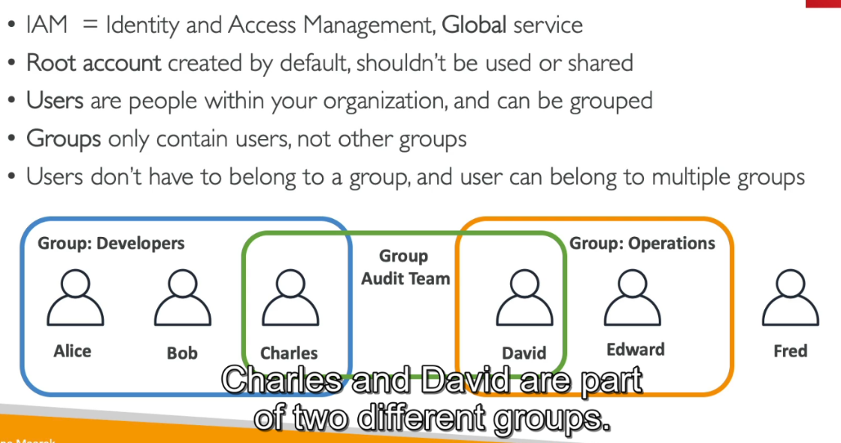

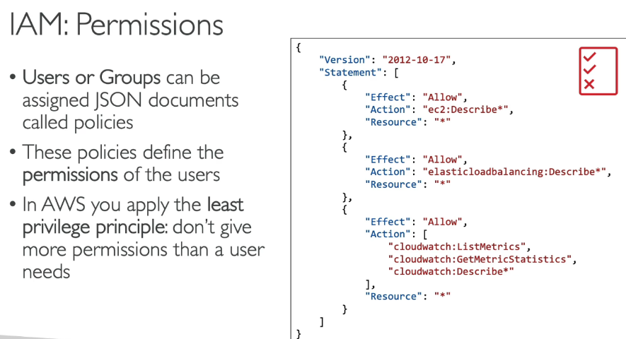**IAM: Permissions**

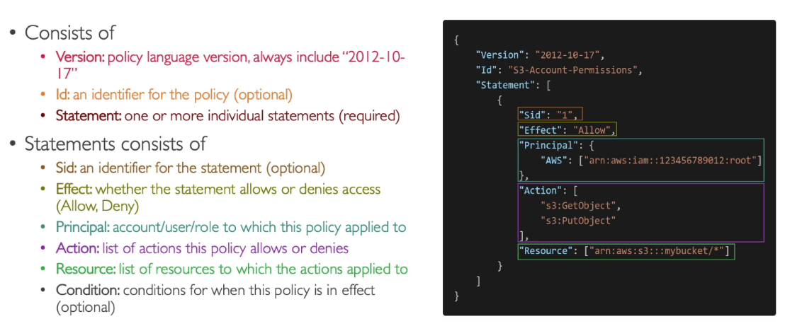**IAM Policies Structure**

**Multi Factor Authentication – MFA**

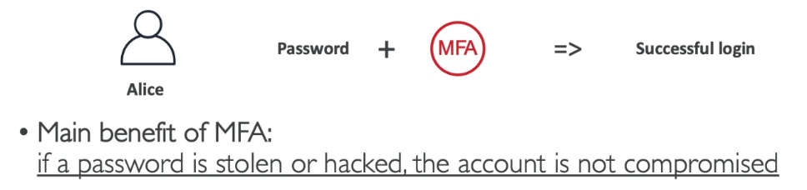Multi-Factor Authentication (MFA) in AWS is a security feature that enhances the protection of AWS accounts and resources by requiring two forms of verification: a password (something you know) and a unique security code generated by a device or app (something you have).

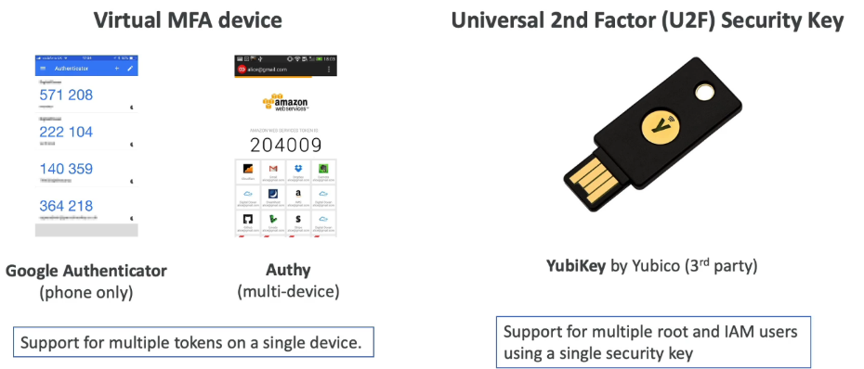**MFA Devices options in AWS**

Universal 2nd Factor (U2F) security keys are hardware-based authentication devices that provide a strong second layer of security for online accounts and systems. U2F keys use public-key cryptography to verify user identities without sharing sensitive information, protecting against phishing and man-in-the-middle attacks. There’s more

**How can users access AWS?**

* **AWS Management Console**:  
  A web-based graphical user interface (GUI) that allows users to manage AWS services and resources visually. It’s ideal for tasks like configuring services, monitoring, and basic management. Accessible via a browser.
* **AWS Command Line Interface (CLI)**:  
  A text-based interface that enables users to interact with AWS services programmatically by typing commands in a terminal. It is suited for automating tasks, managing resources at scale, and integrating with scripts.

**We need to install AWS CLI from google before using command**: aws --version

* **AWS Software Development Kits (SDKs)**:  
  The AWS Software Development Kit (SDK) is a set of libraries and tools provided by AWS to enable developers to interact programmatically with AWS services from their applications.

SDKs for languages like Python (Boto3), Java, JavaScript, and others allow developers to programmatically interact with AWS services within their applications. Useful for building custom applications or automating workflows.

Embedded within your application

* **AWS CloudShell**:  
  A browser-based shell provided within the AWS Management Console. It includes the AWS CLI and is pre-configured with credentials to manage resources directly from the console without additional setup.
* **AWS API**:  
  AWS provides a rich set of APIs that users can call directly using HTTPS requests to interact with AWS services. This method is suitable for advanced integrations and when direct RESTful interactions are needed.

Access keys are generated through the AWS Console

Users manage their own access keys. Access keys are secret, just like a password. Don’t share

**Access Key ID ~= Username**

**Secret Access Key ~= Password**

**Create AWS Access Key**

1. Click on username
2. Security Credentials> CLI> create access key
3. On command prompt: aws configure. It will ask you for the AWS Access Key ID, AWS Secret Access Key and default region name

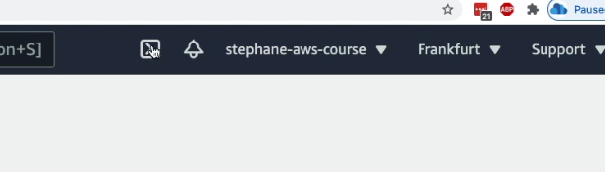**AWS CloudShell**

AWS CloudShell is a browser-based shell environment that allows users to securely manage AWS resources without needing to set up a local development environment. Pre-configured with the AWS Command Line Interface (CLI), CloudShell provides instant access to a terminal directly from the AWS Management Console, eliminating the need for manual credential configuration.

It includes popular tools like Python, Node.js, and Git, and allows users to upload or download files to and from the shell environment.

CloudShell runs in a managed Amazon Linux 2 environment, offering up to 1 GB of persistent storage for each AWS Region to save scripts or configuration files. It is especially useful for quick, ad-hoc tasks like running CLI commands, testing scripts, or managing resources across regions.

**IAM Roles for Services**

IAM roles for services in AWS allow resources, such as EC2 instances, Lambda functions, or ECS tasks, to securely interact with other AWS services without needing long-term credentials like access keys. These roles define a set of permissions using attached policies, granting resources access to perform specific actions on AWS services.

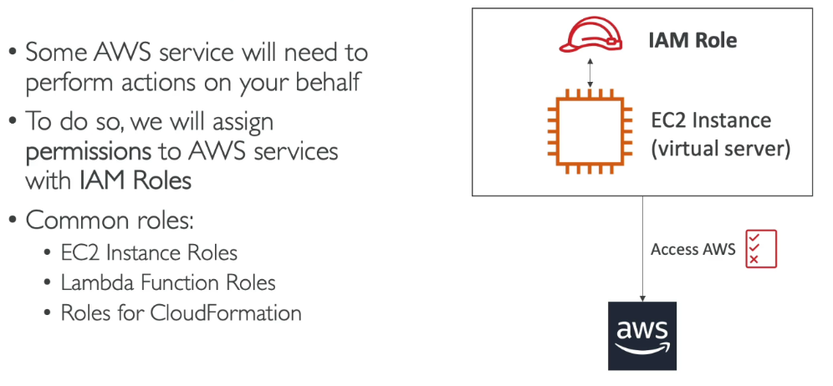For example, an EC2 instance with an assigned IAM role can read from an S3 bucket or publish messages to an SNS topic. IAM roles rely on temporary security credentials provided by the AWS Security Token Service (STS), which automatically rotates them to reduce security risks.

IAM Roles simple means to give aws entities to do stuffs in AWS

**IAM Security Tools**

AWS Identity and Access Management (IAM) security tools are features and services designed to enhance the security of AWS accounts and resources by managing identities and permissions. These include **IAM Policies** for defining granular permissions; **IAM Roles** for granting temporary access to AWS resources without credentials; **IAM Users and Groups** for managing access control for individuals and teams; and **IAM Access Analyzer**, which identifies resource-sharing risks by detecting overly permissive access.

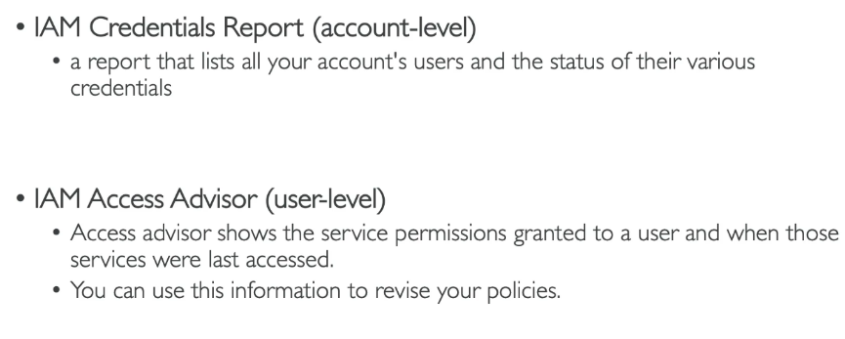**IAM Guidelines & Best Practices**

* Don’t use the root account except for aws account setup
* One physical user = one AWS use
* Assign users to groups and assign [ermissions to grou[s
* Create a strong password policy
* Use and enforce the use of Multi Factor Authentication(MFA)
* Create and use roles for giving permissions to AWS services.
* Use access keys for CLI/SDK
* Audit permissions of your account using IAM Credentials Report & IAM Access Advisor.

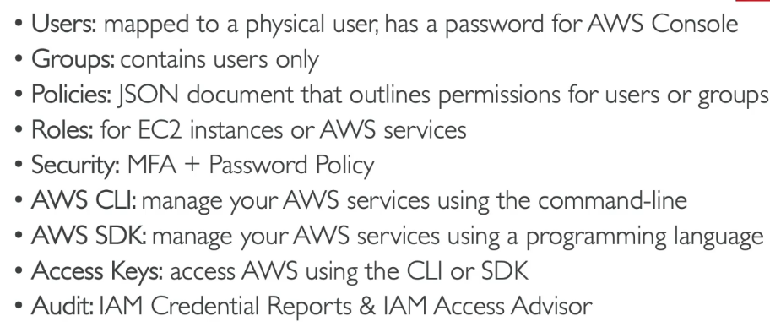**IAM Section – Summary**

1. **EC2 Fundamentals**

Amazon Elastic Compute Cloud (EC2) is a core AWS service that provides scalable, resizable virtual servers in the cloud, designed to run applications of any scale. EC2 offers various instance types optimized for different use cases, such as compute, memory, storage, or GPU-intensive workloads.

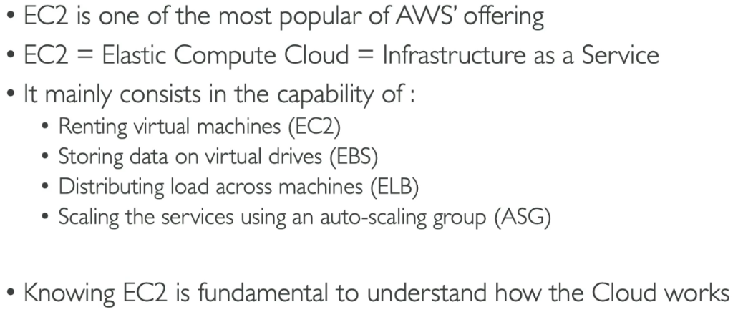It supports customizable configurations, including the choice of operating systems (Linux, Windows), storage options (EBS, instance store), and networking features (Elastic IPs, VPCs, Security Groups). EC2 instances can be launched in multiple purchasing models: **On-Demand** for flexibility, **Reserved Instances** for cost savings, **Spot Instances** for unused capacity at a discount, and **Savings Plans** for predictable workloads.

Auto Scaling ensures dynamic resource allocation based on demand, while features like Load Balancers distribute traffic for high availability

**AWS Budget Setup**

AWS Budgets is a cost management tool that allows you to plan, track, and control your AWS spending and usage. By setting up budgets, you can monitor your costs or usage against defined thresholds and **receive alerts** when they exceed or approach those limits.

Click on my account> My billing Account>Budgets> Create a budget

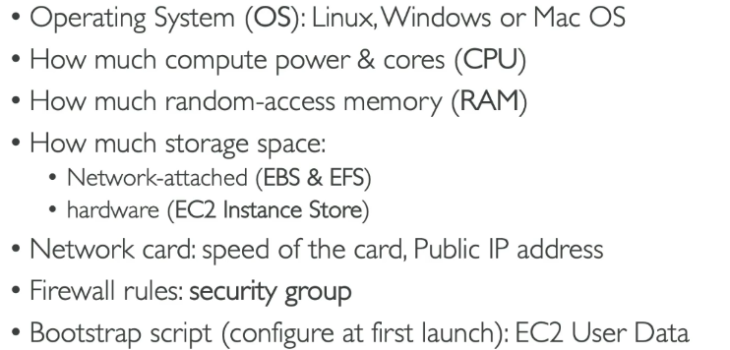**EC2 Sizing & Configuration Options**

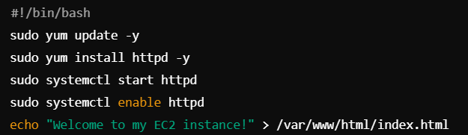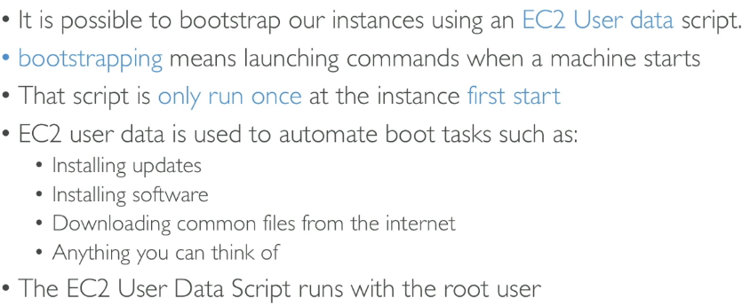EC2 bootstrapping refers to the process of automating the configuration or setup of an Amazon EC2 instance during its launch. This is typically achieved using **user data**, a script or set of commands provided when launching the instance.

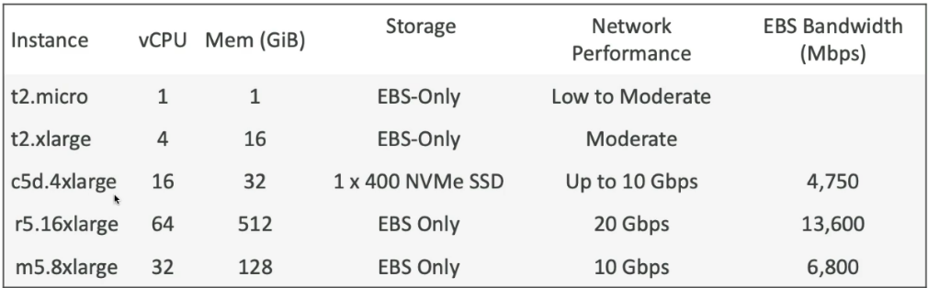**EC2 Instance Types**

<https://aws.amazon.com/ec2/instance-types/>

<https://www.ec2instances.info/>

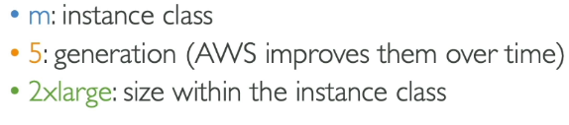**m5.2xlarge**

* **General Purpose**

**Balanced performance** across compute, memory, and networking.

Suitable for web servers, app development, small databases, and general workloads.

Examples:

* + **t4g, t3, t2 (Burstable Performance)**: Cost-efficient for light workloads.
  + 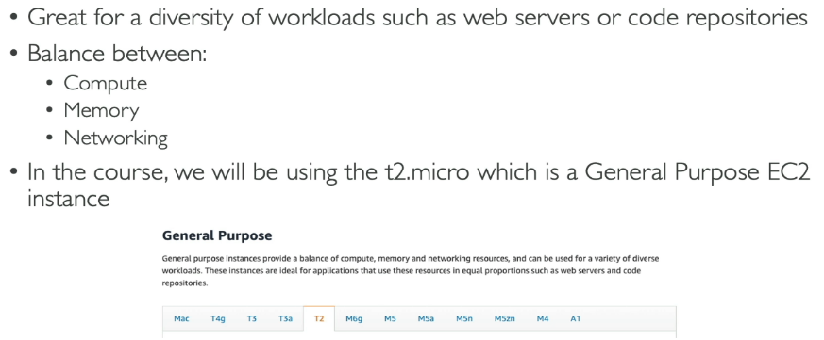**m6i, m5, m4**: Balanced for diverse applications.
* **Compute Optimized**

High-performance processors for **compute-intensive tasks** like high-performance web servers, data analytics, and scientific modeling.

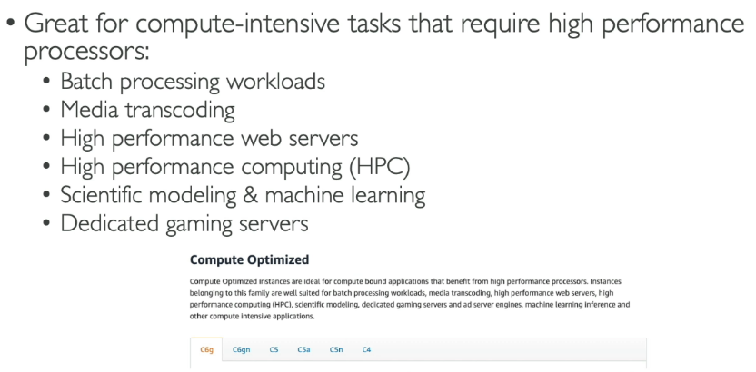Examples: **c7g, c6i, c5, c4**.

* **Memory Optimized**

High memory-to-CPU ratio for **memory-intensive applications**, such as in-memory databases, caching, or big data processing.

Examples:

* + **r6g, r5, r4**: Optimized for general memory use.
  + **x2idn, x1e**: High memory for databases.
  + 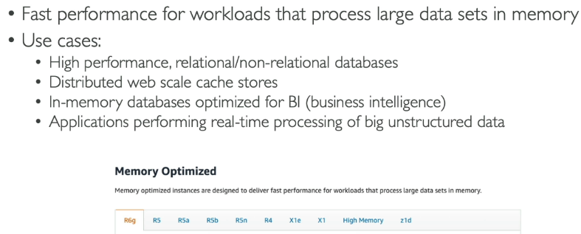**u-6tb1, u-12tb1**: Ultra-high memory for SAP HANA.
* **Storage Optimized**

High local storage throughput for workloads requiring **high, sequential read and write access to large datasets**, like NoSQL databases or data warehousing.

Examples:

* + **i3, i4i**: High IOPS SSDs for storage-intensive tasks.
  + **d2, d3**: Dense HDD storage for big data.
  + 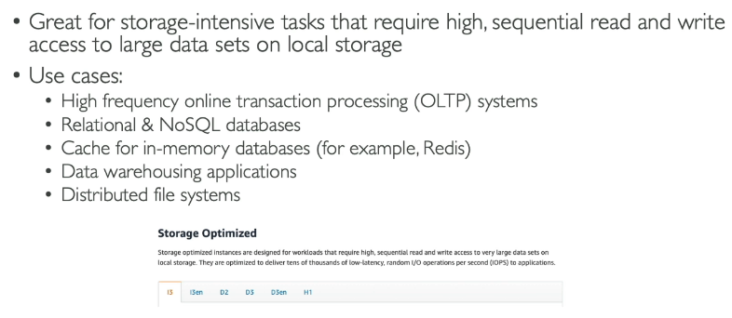**h1**: Optimized for disk throughput.
* **Accelerated Computing (GPU)**

Specialized hardware (GPUs, FPGAs) for **machine learning, AI inference, graphics rendering, and scientific computing**.

Examples:

* + **p4, p3**: For AI training and deep learning.
  + **g5, g4dn**: GPU-based for inference and gaming.
  + **f1**: FPGA instances for custom hardware acceleration.
* **High Performance Computing (HPC)**

Optimized for **massive parallel computing**, such as weather simulations or molecular modeling.

Examples: **hpc6id, c5n**.

**Security Groups**

Security Groups in AWS act as virtual firewalls for your EC2 instances, controlling inbound and outbound traffic at the instance level. They are stateful, meaning changes in inbound rules automatically reflect in the corresponding outbound rules. Each Security Group consists of rules that specify allowed traffic based on protocol (e.g., TCP, UDP, ICMP), port range, and source or destination IP address or CIDR blocks

By default, Security Groups deny all inbound traffic and allow all outbound traffic, requiring explicit rules to permit desired communication. They are region-specific and can only be assigned to instances in the same VPC.

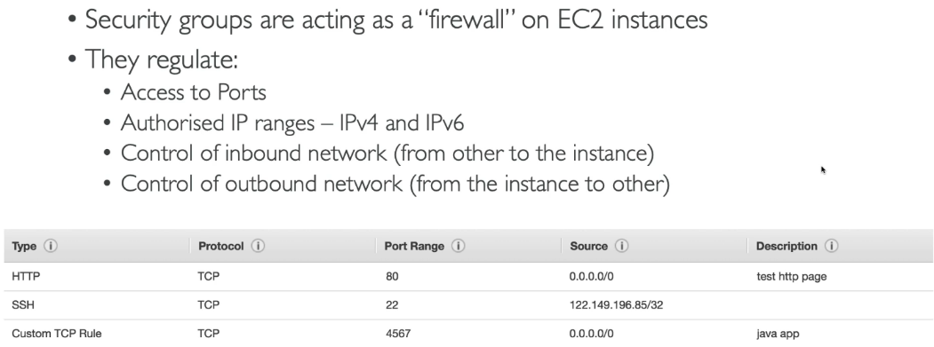Security group can refence by ip or by security group

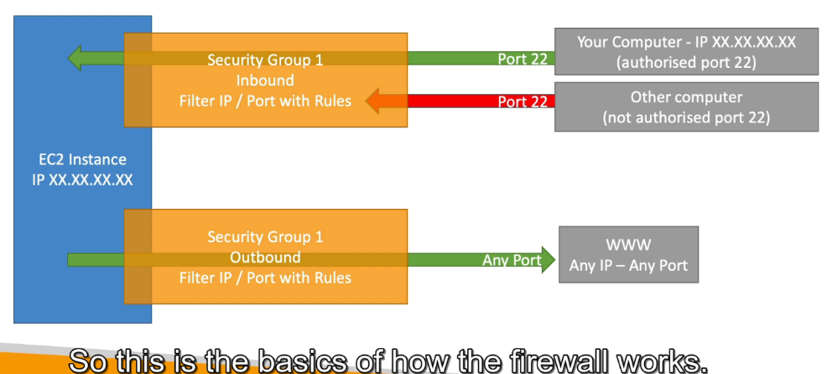**Security Group Diagram**

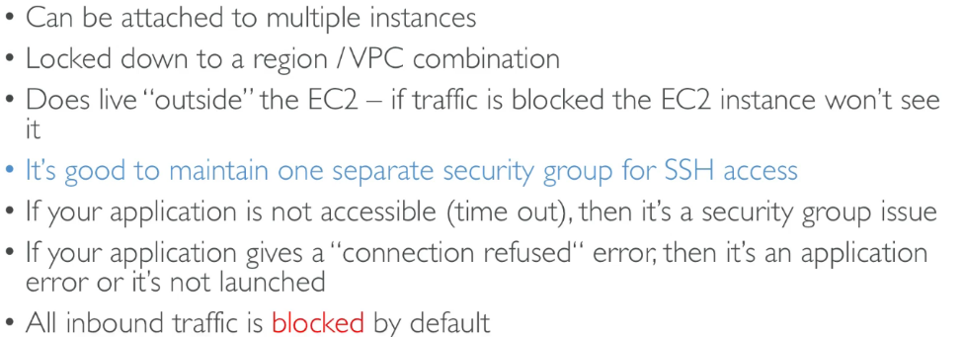

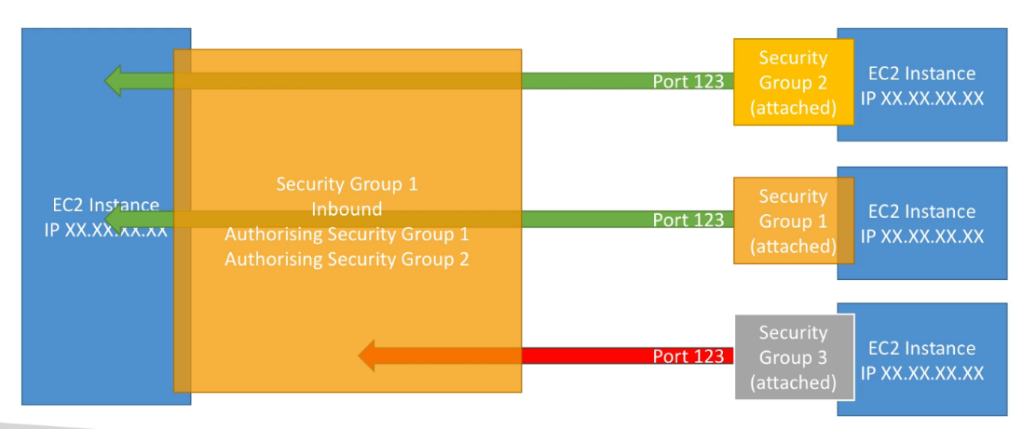**Referencing other security groups features**

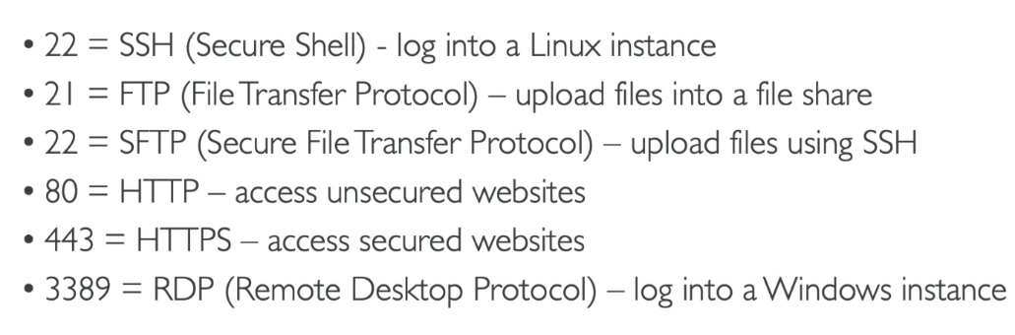 **Some port you need to know**

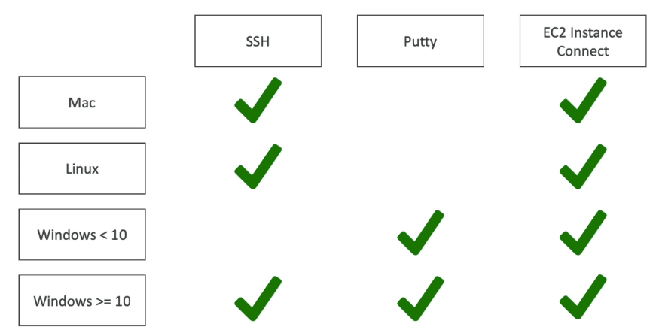**SSH Summary Table**

**How to SSH into your EC2 Instance**

To "SSH into your EC2 instance" means to establish a secure shell (SSH) connection to a virtual server (EC2 instance) running on AWS. This is done using an SSH client and the private key associated with the EC2 instance's key pair. The process allows you to remotely access and manage the instance, enabling tasks like configuring software, troubleshooting, or deploying applications.

For that you need to download the pem file of your ec2 and inside that directory write this command(you also need public ip):

ssh -i your-key.pem ec2-user@<instance-public-IP>

For Windows 7-8 use putty.

**Using EC2 Instance Connect**

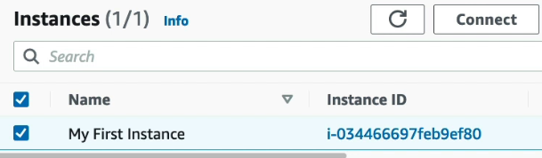This allows you to do browser-based connection to your ec2 instance. There will be an option to connect to your ec2 instance inside your dashboard.

**EC2 instance IAM Roles**

With IAM roles, you attach the role to the instance, and AWS automatically provides temporary credentials via the instance metadata service, eliminating the need to store sensitive credentials like access keys on the instance. This reduces the risk of credential exposure, supports dynamic credential rotation, and ensures compliance with security best practices.

**EC2 Instance Purchasing Options**

* 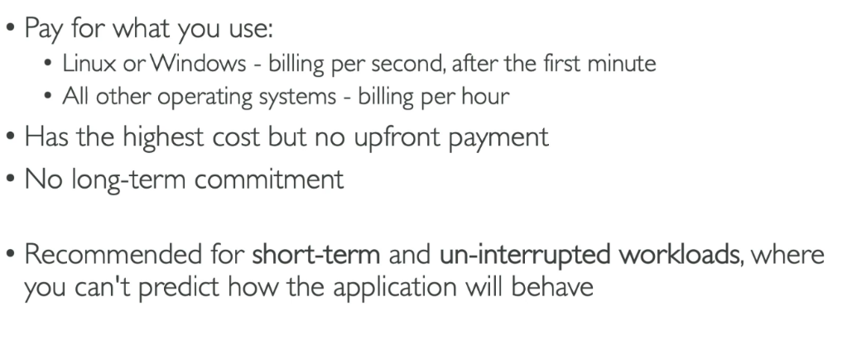**On demand Instance**
* 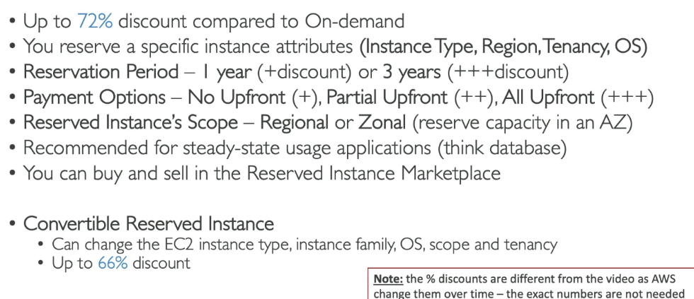**EC2 reserved Instance**
* **EC2 Savings Plans**

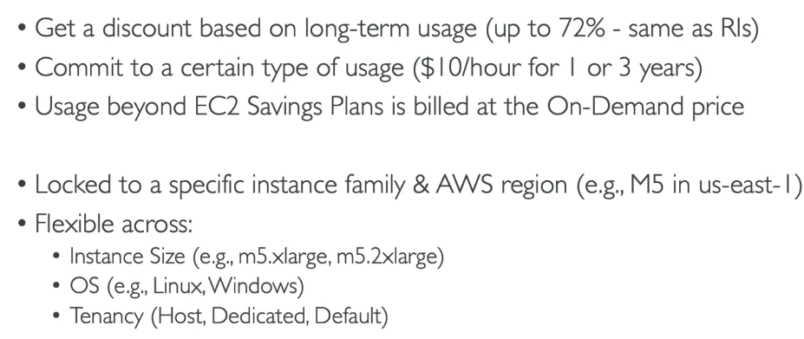Flexible pricing models offering lower rates in exchange for a commitment to a consistent amount of compute usage (measured in $/hour) over 1 or 3 years.

* **EC2 Spot Instance**

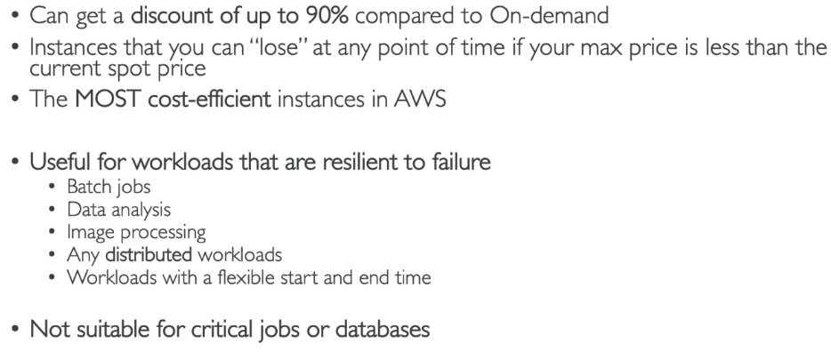Purchase unused EC2 capacity at up to 90% off the On-Demand price. Great for fault-tolerant, flexible applications like big data processing, CI/CD, and batch jobs. These are unused EC2 instances that AWS offers at a discount (up to 90%) because they aren’t being used by other customers. You can bid for these instances or just request them at the current Spot price. if the Spot price exceeds your bid or AWS needs the capacity back, your instance may be interrupted (shut down with short notice).

* **EC2 Dedicated Host**

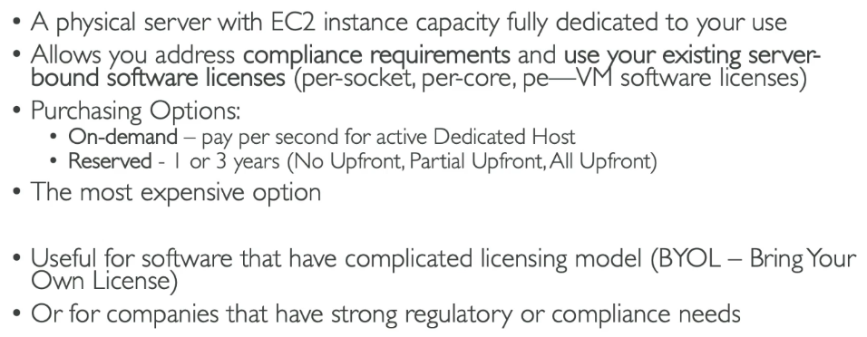Instances that run on hardware dedicated to a single customer.

* 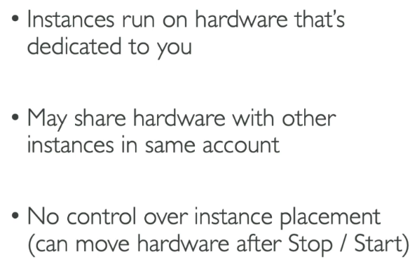**EC2 Dedicated instances**

|  |  |  |
| --- | --- | --- |
|  | EC2 Dedicated Host | EC2 Dedicated Instance |
| Physical Server Control | Full control over the physical server, including socket and core visibility. | No control over the physical server; AWS manages placement. |
| Licensing | Supports Bring Your Own License (BYOL) for software that requires physical server mapping (e.g., Windows, SQL). | Limited licensing options; does not support detailed BYOL requirements. |
| Instance Placement | Instances are placed on a specific, identifiable physical server. | Instances are placed on hardware dedicated to you but without visibility. |
| Compliance Needs | Suitable for compliance scenarios needing hardware-level assurance (e.g., HIPAA, PCI). | Suitable for general compliance but lacks detailed hardware mapping. |

* **EC2 Capacity Reservations**

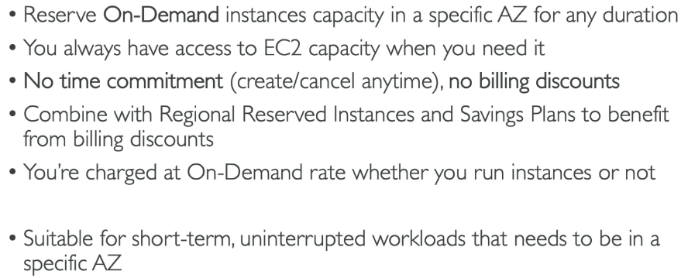Reserve capacity in a specific Availability Zone for On-Demand instances. Useful for ensuring availability during high-demand periods.

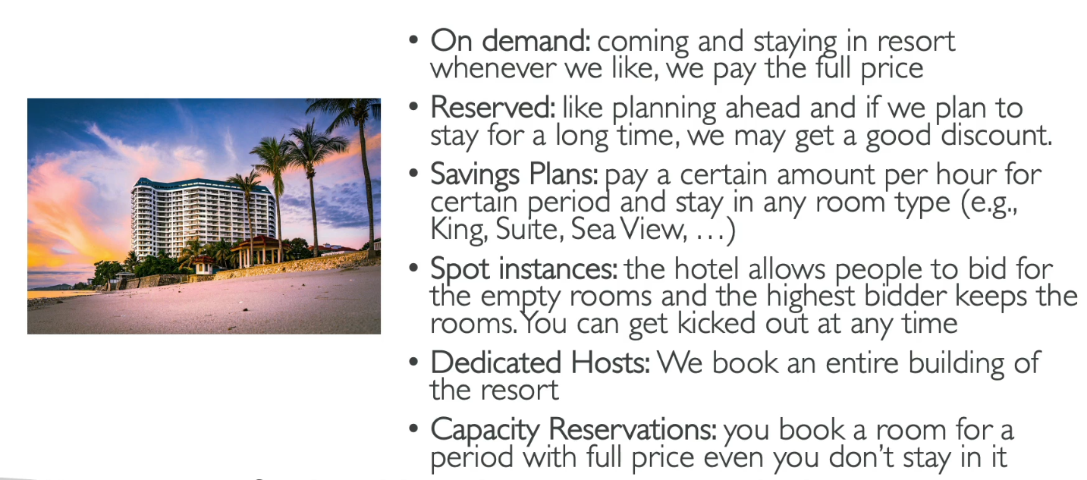**Which Purchasing is right for me?**

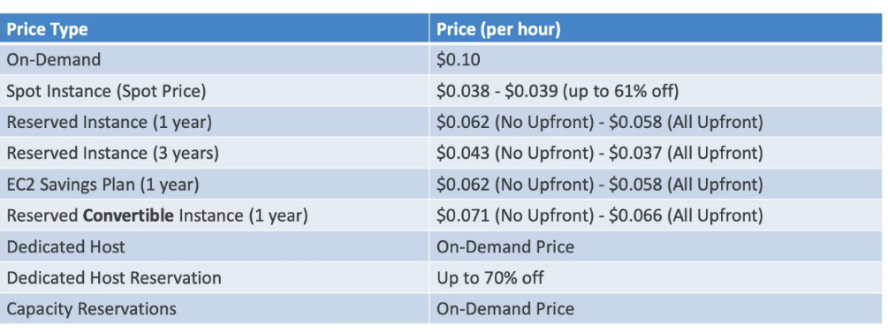**Price comparison (m4.large-us-east-I)**

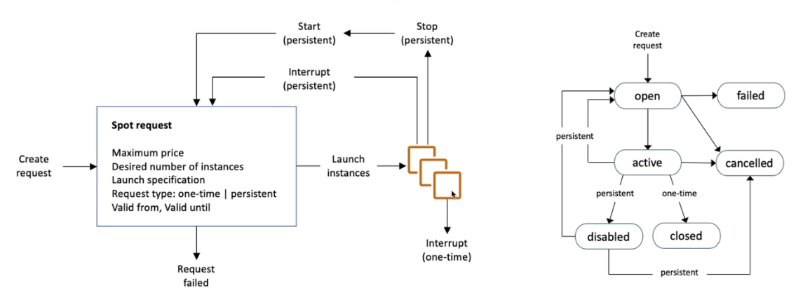**Spot instance workflow**

A Spot Instance Request in AWS allows you to request unused EC2 capacity at a significantly lower price than On-Demand instances by specifying the instance type, region, and maximum price you are willing to pay. AWS checks the current Spot Price, and if your bid is equal to or higher than the price, it fulfills your request and launches the instance.

**One-Time Request**: The request is fulfilled only once, and if interrupted, it won’t be retried.

**Persistent Request**: The request is automatically retried if interrupted, ensuring continuous availability.

**Valid From**: Specifies the start time when the request becomes active.

**Valid Until**: Specifies the expiration time, after which the request is canceled if not fulfilled.

**Spot Fleets**

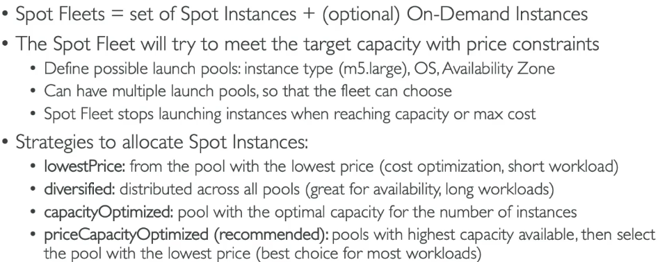A **Spot Fleet** in AWS is a collection of Spot Instances and optionally On-Demand Instances managed as a group to optimize cost and availability. Spot Fleets allow you to define a fleet configuration by specifying instance types, pricing models, and target capacity, and AWS automatically provisions the optimal mix of instances based on availability and cost.

1. **EC2-SAA level**

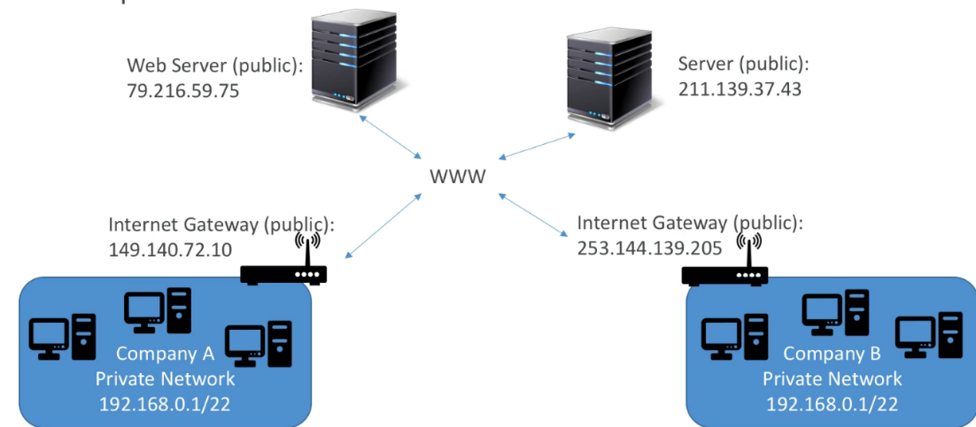**Public vs private IP**

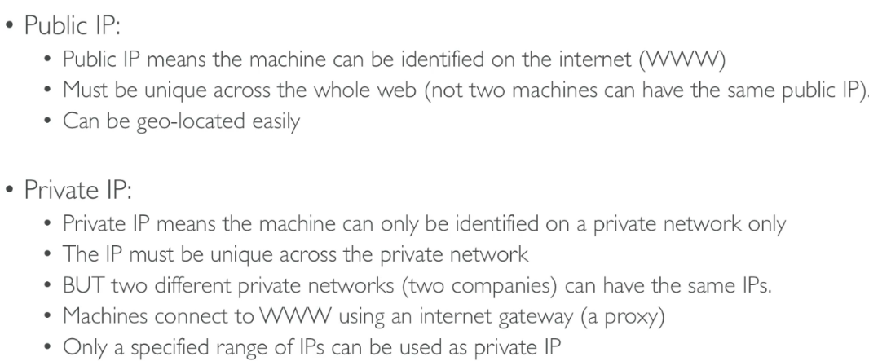When you have public ip youre accessible over the internet and when you have a private ip youre accessible within the private network

**Elastic IP**

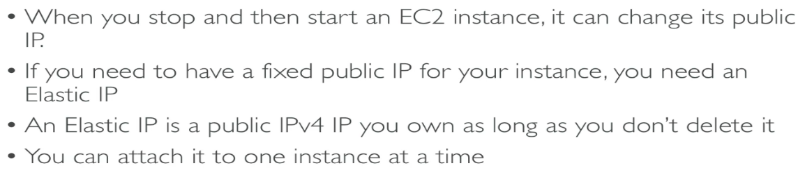An **Elastic IP (EIP)** in AWS is a static, public IPv4 address that you can allocate and associate with an EC2 instance, network interface, or other AWS resources within a VPC. Unlike standard public IPs, EIPs remain constant even if you stop or restart your instance, making them ideal for applications requiring a fixed public endpoint, such as web servers or APIs.

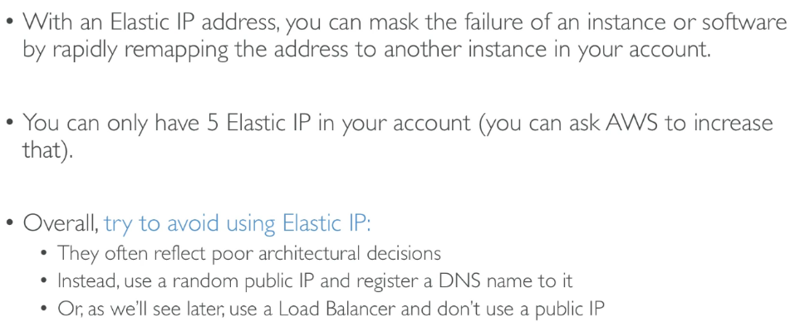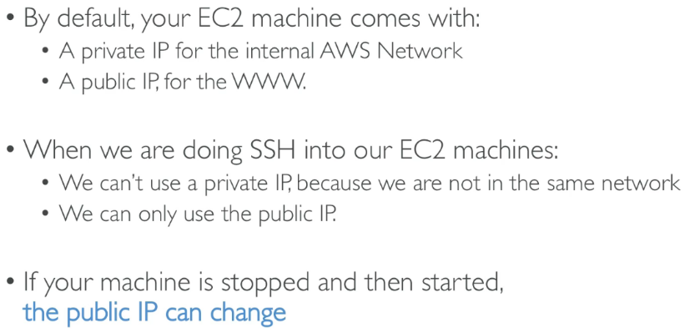

**EC2 Placement Group**

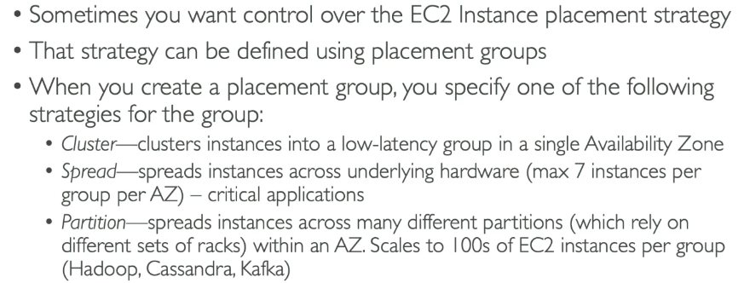An **EC2 Placement Group** is a logical grouping of instances within a single Availability Zone or across multiple zones in AWS. It helps optimize the networking and performance of EC2 instances, depending on the workload requirements. Understanding EC2 Placement Groups is essential for efficiently architecting solutions on AWS.

* **Cluster Placement Groups**

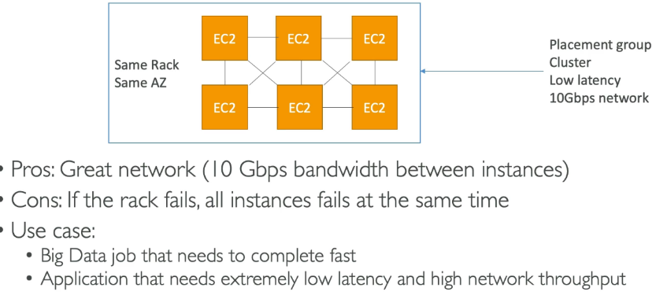Groups instances close together in a single Availability Zone to optimize low-latency and high-throughput networking.

* **Spread Placement Group**

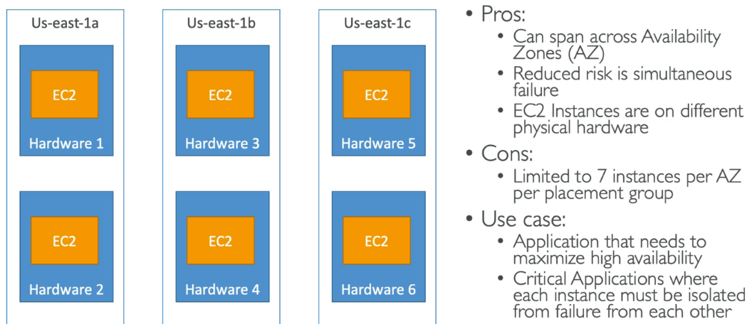Distributes instances across underlying hardware to reduce the impact of hardware failure.

* 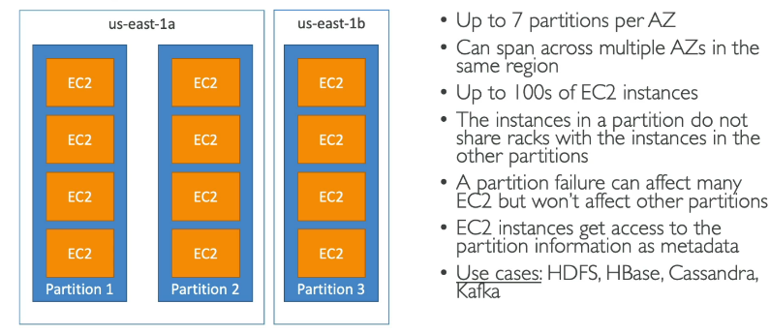**Partition Placement Group**

|  |  |  |
| --- | --- | --- |
|  | Spread placement Group | Partition Placement group |
| Purpose | Keeps each instance on separate hardware. | Groups instances into isolated hardware partitions. |
| Fault Isolation | If one instance fails, others are safe (each is on its own hardware). | If one partition fails, others are safe (each partition is separate). |
| Max Instances | Only up to 7 instances per Availability Zone. | Can handle hundreds of instances. |
| Hardware Sharing | Each instance has its own hardware. | Instances in the same partition share hardware. |
| Use Case | Critical applications needing individual isolation. | Large distributed systems like Hadoop or Cassandra. |
| Scalability | Limited because of the 7-instance limit. | Highly scalable with multiple partitions. |

**Elastic Network Interfaces(ENI)**

Elastic Network Interface (ENI) in AWS is a virtual network card that attaches to an EC2 instance, providing network connectivity within a Virtual Private Cloud (VPC).

ENIs are flexible and can have one or more private IPv4 addresses, a public IPv4 address, multiple security groups, and an associated Elastic IP (EIP).

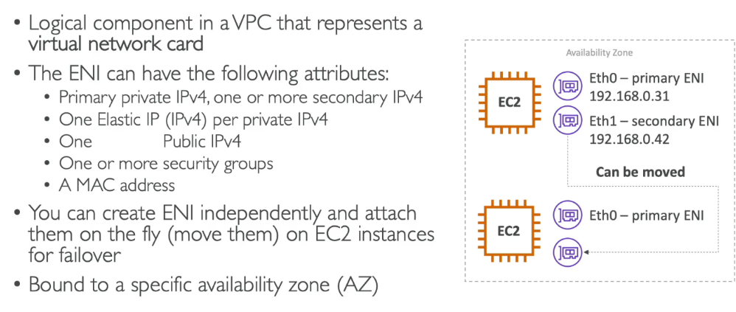ENIs are highly useful for implementing network configurations like load balancing, high availability, failover, or monitoring by moving an ENI between instances without disrupting traffic.

Here’s why secondary private IPs are needed on an EC2 instance using ENI:

Host multiple applications with separate IP addresses.

Enable load balancing for traffic distribution.

Support failover and high availability.

Isolate traffic for multi-tenant applications.

Set up custom routing for specific traffic.

**EC2 Hibernate**

EC2 **Hibernate** is a feature that allows you to pause an EC2 instance and resume it later, preserving the in-memory state of the instance, including all running applications and processes.

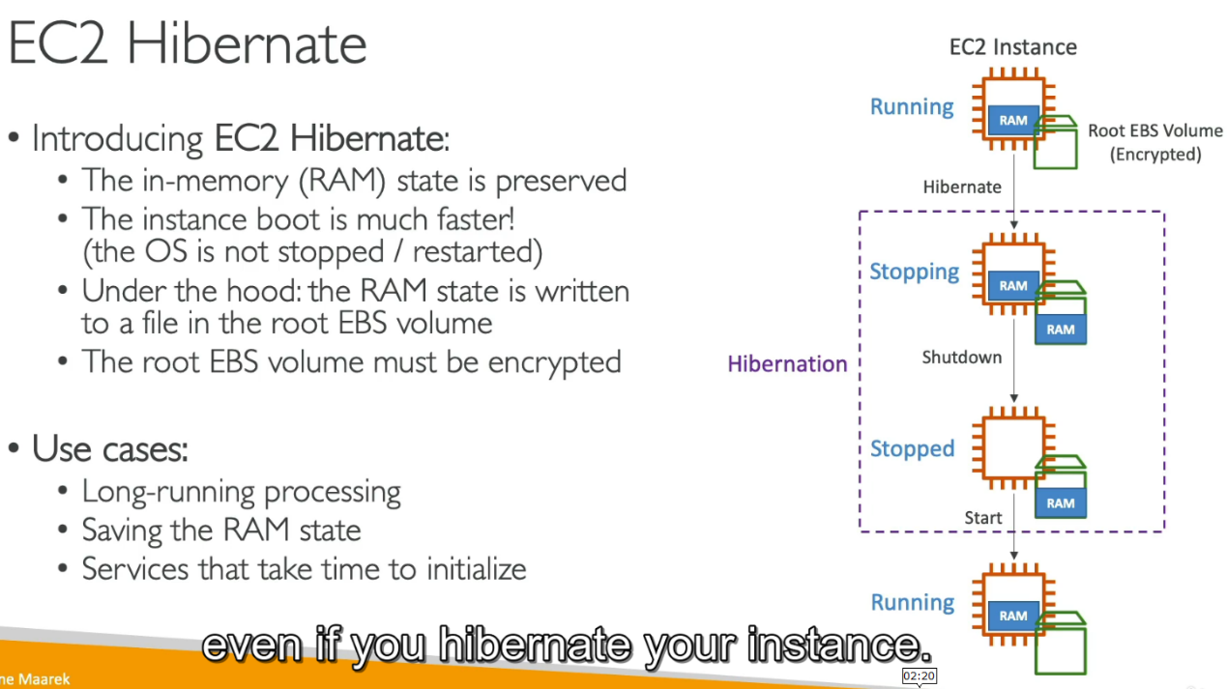When an instance is hibernated, AWS saves the contents of the instance’s RAM (memory) to the **Amazon Elastic Block Store (EBS) root volume**, allowing it to restart exactly where it left off. **Amazon Elastic Block Store (EBS)** is a scalable, high-performance block storage service provided by AWS that is used to store data for EC2 instances. EBS volumes act like hard drives or SSDs that you can attach to your EC2 instances, enabling persistent storage.

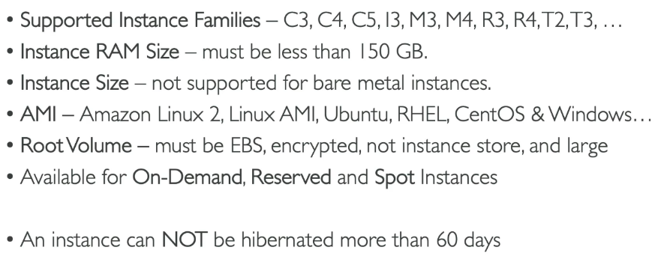**EC2 Hibernate- Good To know**

1. **EC2 Instance Storage Section**

**EBS Volume**

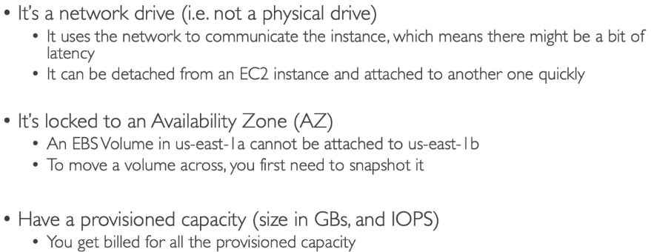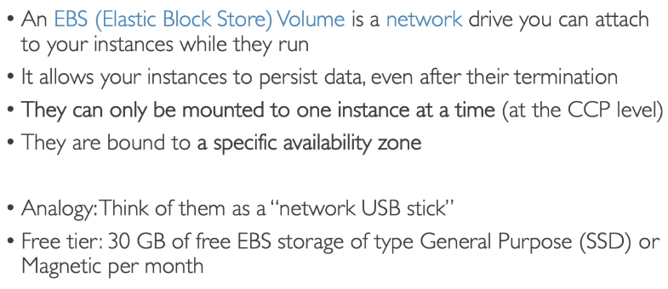Amazon Elastic Block Store (EBS) is a scalable, high-performance block storage service designed for use with Amazon EC2 instances. It provides persistent, reliable storage that retains data even after the EC2 instance it is attached to is stopped or terminated.

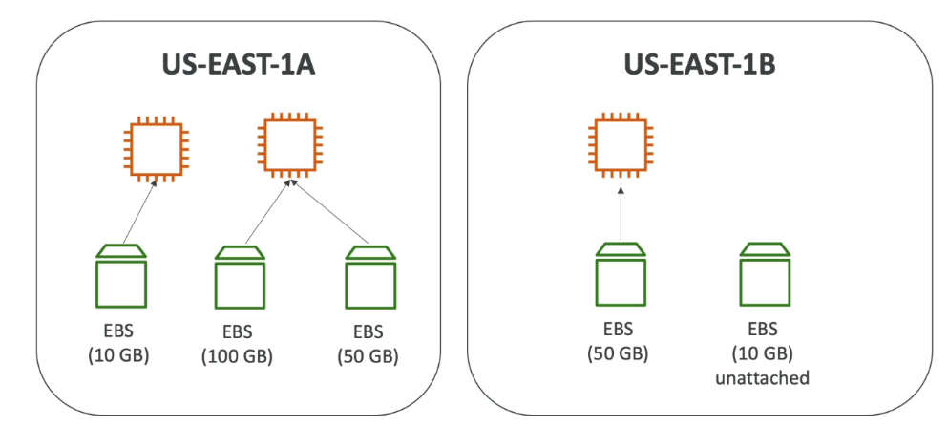

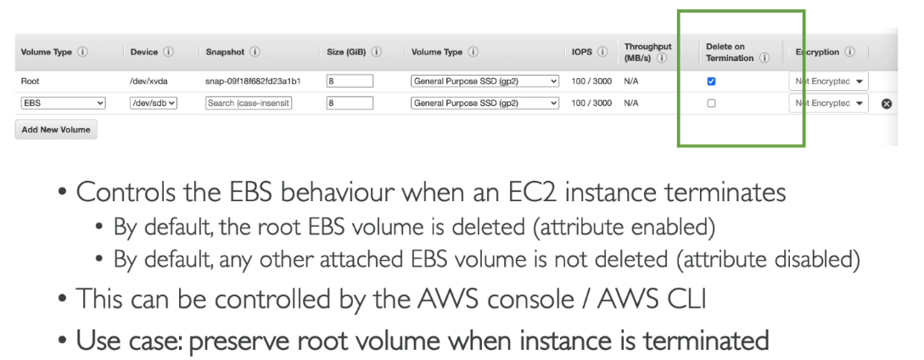**EBS- Delete On Termination Attribute**

The "Delete on Termination" attribute in Amazon Elastic Block Store (EBS) determines whether an EBS volume is automatically deleted when its associated EC2 instance is terminated.

By default, this attribute is enabled for the root volume (the volume that contains the instance's operating system) and disabled for additional (non-root) volumes, though this can be adjusted. When enabled, the volume and its data are permanently deleted upon instance termination, simplifying resource cleanup and cost management. If disabled, the volume persists even after the instance is terminated, allowing you to retain the data for future use or attach the volume to another instance.

**EBS Snapshot**

An Amazon Elastic Block Store (EBS) snapshot is a point-in-time backup of an EBS volume, stored in Amazon S3.

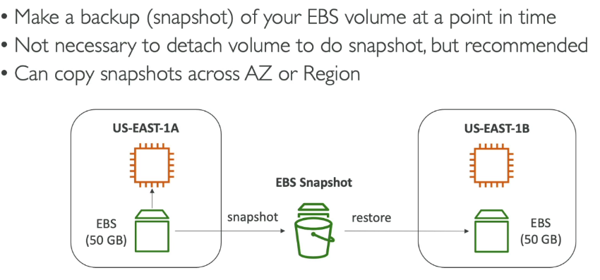Snapshots are incremental, meaning they only save changes made since the last snapshot, optimizing storage costs. They can be used to restore data by creating new EBS volumes from the snapshot in the same or different AWS region, facilitating disaster recovery, migration, or scaling.

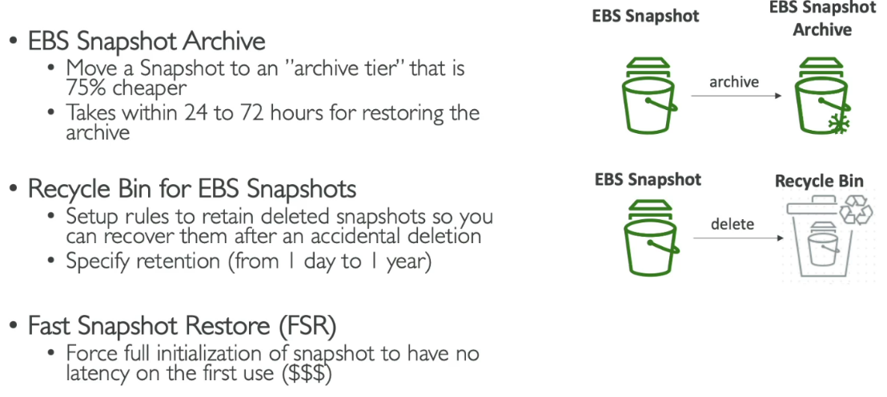**EBS Snapshot Features**

**Amazon Machine Language**

An Amazon Machine Image (AMI) in AWS is a pre-configured template that provides the information required to launch a virtual server, known as an EC2 instance. It includes a base operating system (Linux, Windows, etc.), application software, and any custom configurations, making it reusable and scalable.

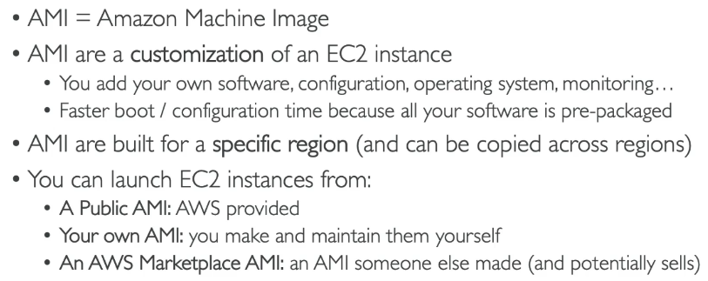AMIs are region-specific but can be copied across regions. They are categorized into public, private, and shared, enabling tailored or community-driven setups.

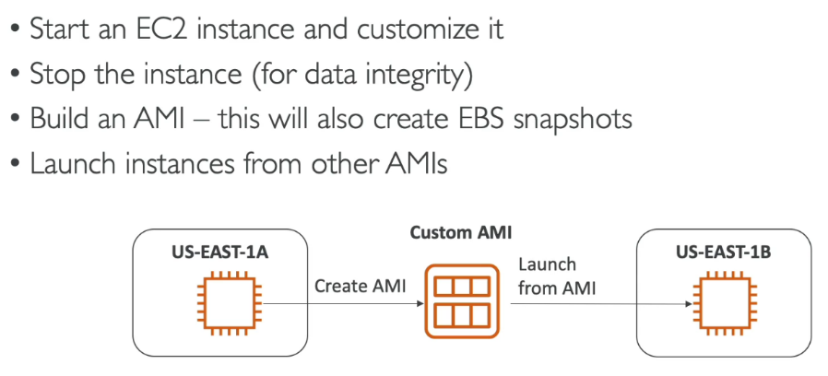**AMI Process (From an Ec2 Instance)**

**EC2 Instance Store**

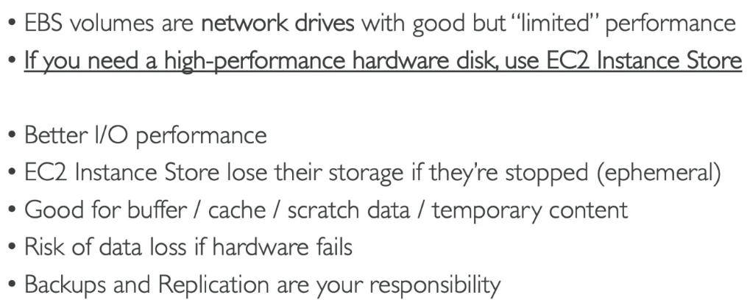An EC2 Instance Store in AWS provides temporary block-level storage for EC2 instances, physically attached to the host server. It is designed for high-performance ephemeral storage, ideal for temporary data like buffers, caches, and scratch data.

|  |  |  |
| --- | --- | --- |
| Feature | EBS (Elastic Block Store) | EC2 Instance Store |
| Persistence | Data persists even when the instance stops or terminates. | Data is lost when the instance stops or terminates. |
| Backup and Snapshots | Supports snapshots for data backup and recovery. | Does not support snapshots; data is ephemeral. |
| Durability | Highly durable with replication across Availability Zones (AZs). | Not durable; tied to the lifecycle of the instance. |
| Performance | Suitable for a wide range of workloads; performance depends on the volume type (e.g., SSD, HDD). | High throughput and low latency for temporary storage. |
| Storage Type | Network-attached storage (independent of the host). | Physically attached to the host machine. |
| Data Recovery | Data can be recovered from snapshots in case of failure. | Data cannot be recovered once lost. |

**EBS Volume Types**

|  |  |  |  |  |
| --- | --- | --- | --- | --- |
| | **Volume Type** | **Description** | **Use Cases** | **Performance** | | --- | --- | --- | --- | |
| |  |  |  |  | | --- | --- | --- | --- | | **General Purpose SSD (gp3)** | Next-generation SSD offering consistent performance, cost-effective with adjustable IOPS and throughput. | Databases, boot volumes, and workloads requiring moderate IOPS and throughput. | Baseline 3,000 IOPS and 125 MiB/s, scalable up to 16,000 IOPS and 1,000 MiB/s. | |
| |  |  |  |  | | --- | --- | --- | --- | | **General Purpose SSD (gp2)** | Legacy SSD optimized for a balance of price and performance, with burstable IOPS for small workloads. | System boot volumes, small-to-medium databases, and dev/test environments. | Baseline IOPS depends on volume size (3 IOPS per GiB), bursting up to 3,000 IOPS. | |
| |  |  |  |  | | --- | --- | --- | --- | | **Provisioned IOPS SSD (io2)** | High-performance SSD designed for latency-sensitive and IOPS-intensive workloads, with high durability. | Mission-critical databases (e.g., Oracle, MySQL), transactional systems, and large-scale applications. | Up to 64,000 IOPS and 1,000 MiB/s (Nitro-based instances). | |
| |  |  |  |  | | --- | --- | --- | --- | | **Throughput Optimized HDD (st1)** | Low-cost HDD optimized for sequential I/O and high throughput, suitable for big data and log processing. | Streaming workloads, data warehouses, and log processing. | Maximum throughput of 500 MiB/s, performance depends on size and workload. | |
| |  |  |  |  | | --- | --- | --- | --- | | **Cold HDD (sc1)** | Lowest-cost HDD for infrequently accessed data, ideal for archival and cold storage. | Archiving, infrequent backups, and large, cold datasets. | Maximum throughput of 250 MiB/s, designed for infrequent data access. | |

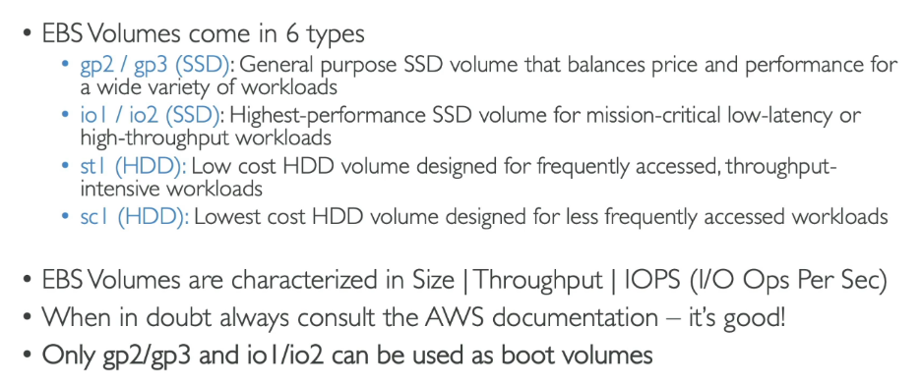

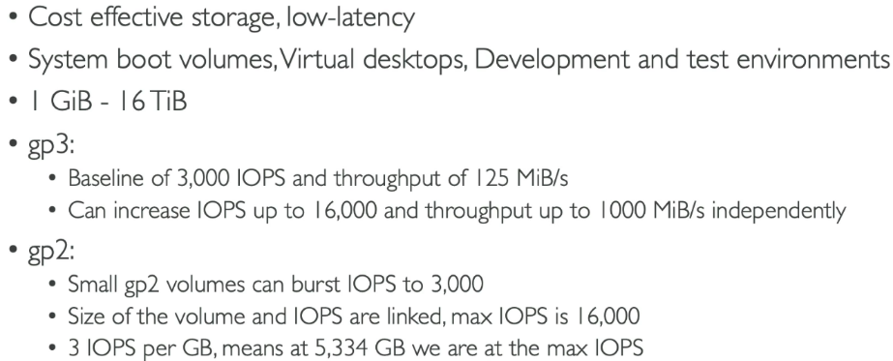**General Purpose SSD**

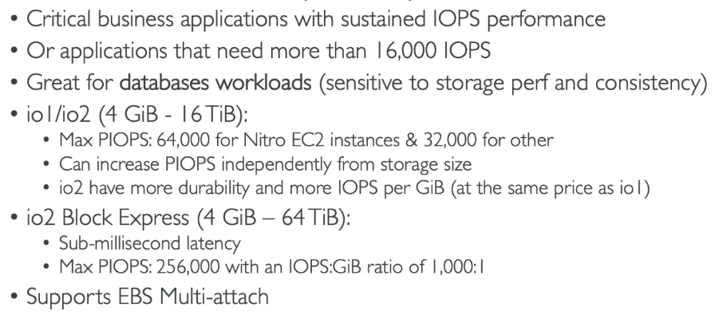**Provisioned IOPS (PIOPS) SSD**

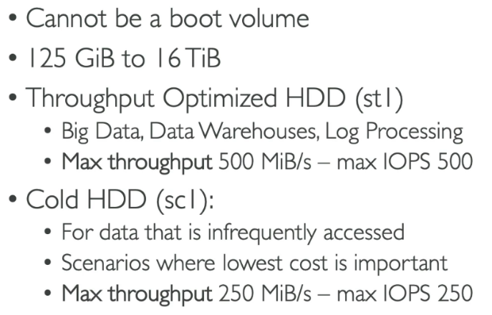**Hard Disk Drives(HDD)**

**EBS Multi Attach- io 1/io 2 family**

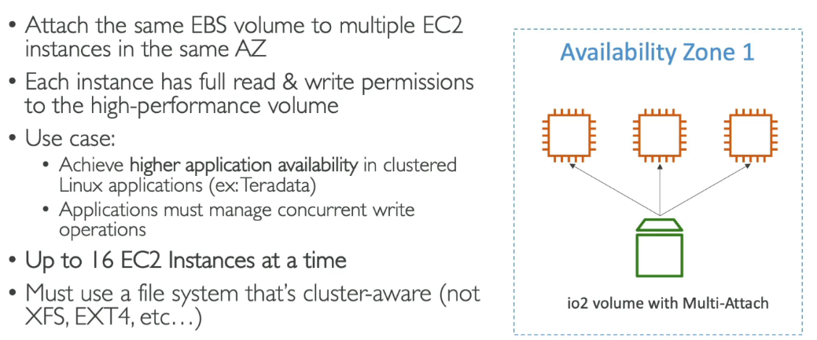**EBS multi-attach** is an AWS feature that allows a single EBS volume (limited to **io1** and **io2** Provisioned IOPS SSD types) to be attached to multiple EC2 instances simultaneously within the same Availability Zone. Each instance gets dedicated IOPS and throughput, making it ideal for clustered or distributed applications like Oracle RAC or high-availability systems requiring shared storage.

When using **EBS Multi-Attach**, a cluster-aware file system is required because traditional file systems like **XFS** or **EXT4** are designed for a single host and cannot handle multiple servers accessing the same storage simultaneously.

**EBS Encryption**

EBS encryption is an AWS feature that secures data at rest, in transit, and during snapshots and volumes creation by using AWS Key Management Service (KMS). When enabled, encryption applies to the EBS volume, its data, snapshots, and any volumes created from those snapshots.

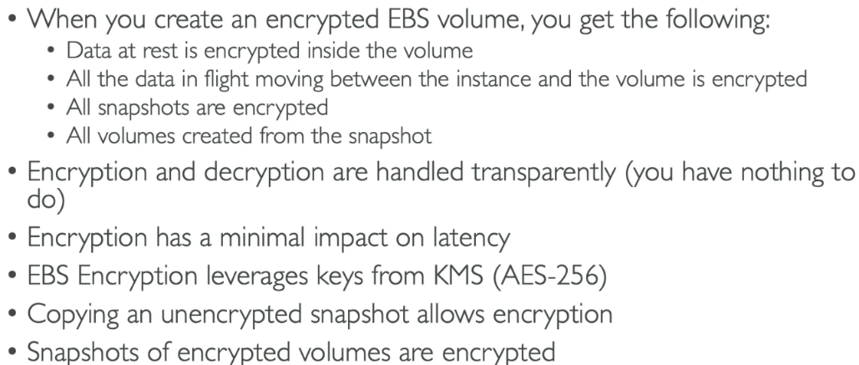The encryption uses AES-256 standards and is completely transparent to users, meaning no application changes are required.

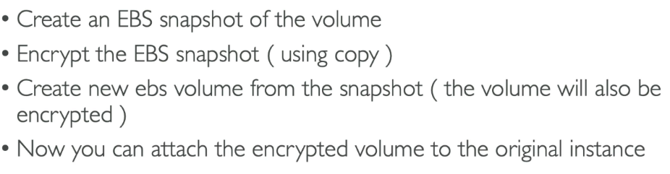**How to Encrypt an unencrypted EBS volume**

**Elastic File System**

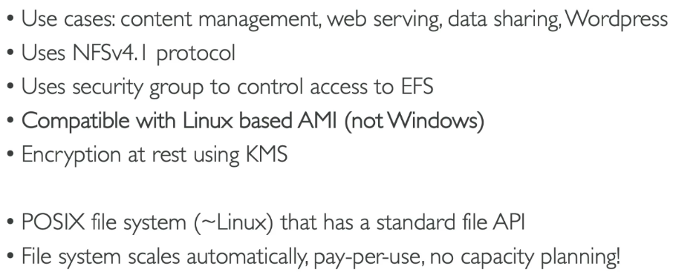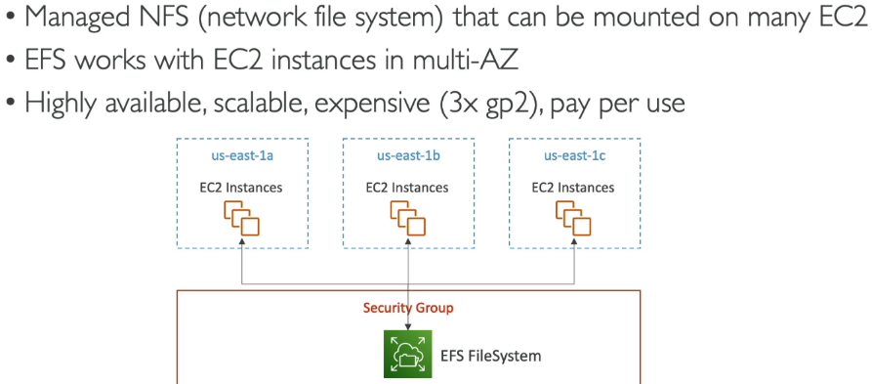Amazon Elastic File System (EFS) is a fully managed, scalable, and elastic Network File System (NFS) designed to provide shared file storage that can be accessed concurrently by multiple EC2 instances, containers, and other AWS services. EFS automatically scales storage capacity as data is added or removed, eliminating the need for manual provisioning.

**Performance and Storage Classes of EFS**

**Performance**

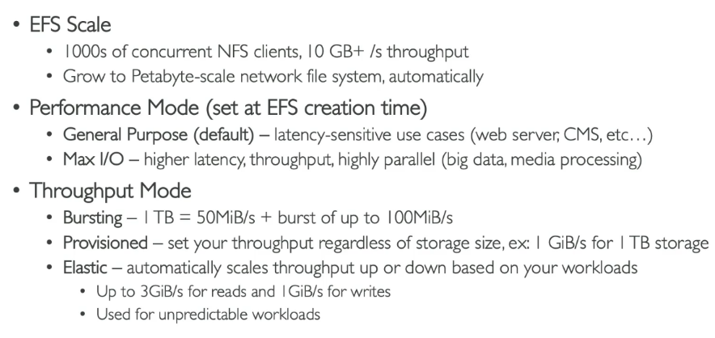

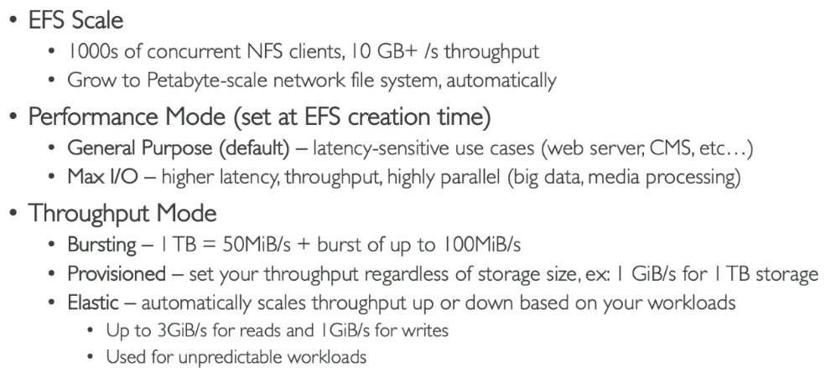**Storage Classes**

**EBS vs EFS**

|  |  |  |
| --- | --- | --- |
| Feature | EBS (Elastic Block Store) | EFS (Elastic File System) |
| Storage Type | Block storage. | File storage. |
| Access | Can be attached to a single EC2 instance at a time. | Can be accessed by multiple EC2 instances simultaneously. |
| Use Case | Applications requiring low-latency, block-level storage. | Applications needing shared access and scalability. |
| Scalability | Predefined size (up to 16 TiB for General Purpose). | Automatically scales up or down based on stored data. |
| Durability | Replicated within a single Availability Zone (AZ). | Replicated across multiple AZs by default. |
| Availability | Limited to the attached instance’s AZ. | Accessible across multiple AZs. |

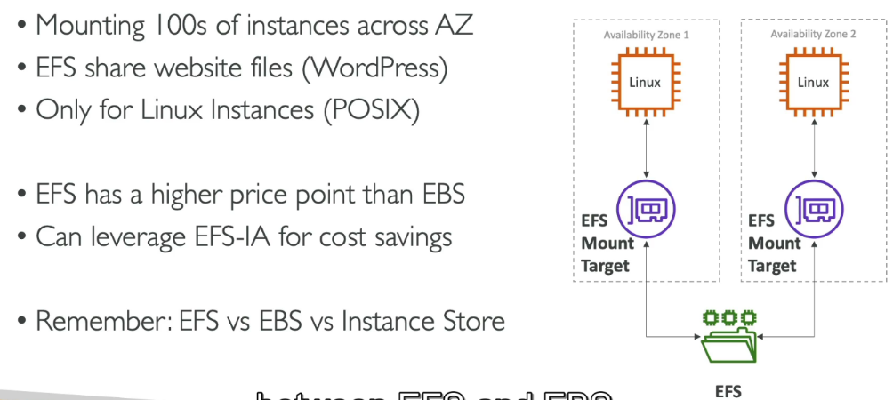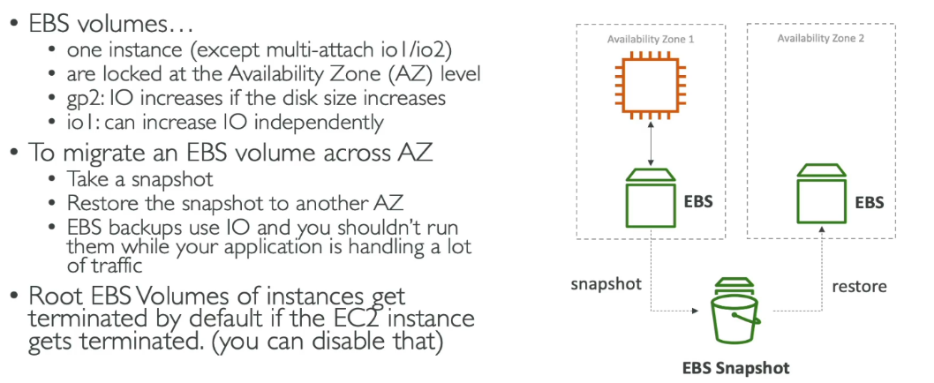

1. **High Availability and Scalability ELB & ASG**

**Scalability**

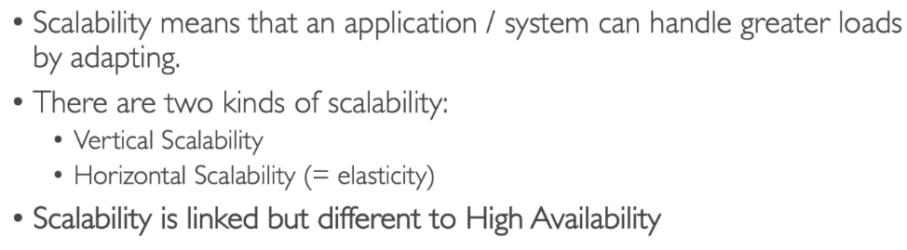In AWS, **scalability** refers to the ability of a system to automatically adjust its resources based on demand, ensuring optimal performance as traffic or workload increases or decreases.

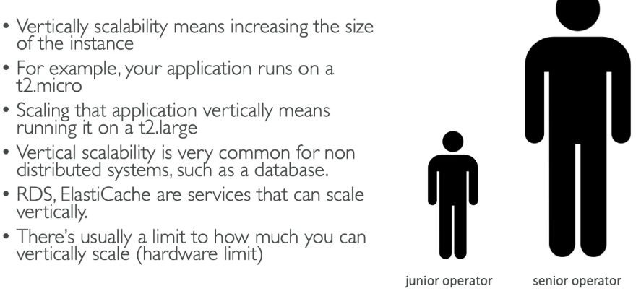**Vertical Scalability**

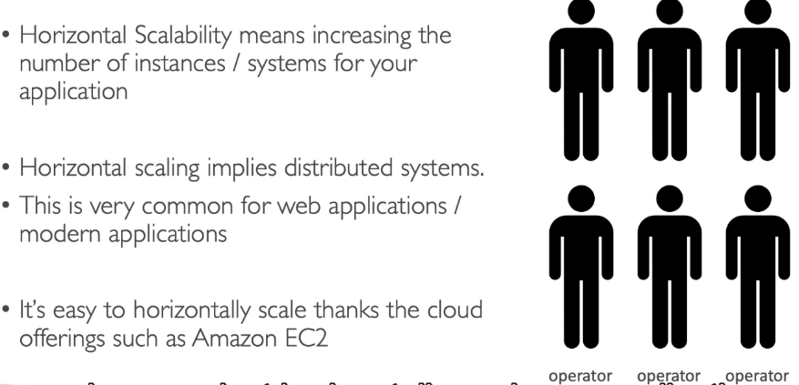**Horizontal Scalability**

**Availability**

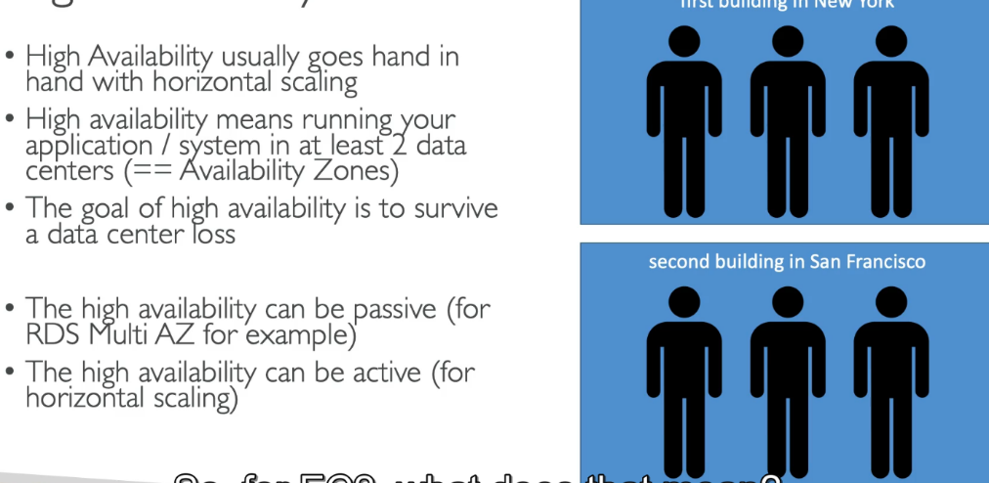**Availability**, on the other hand, refers to the system's ability to remain operational and accessible even in the event of failure.

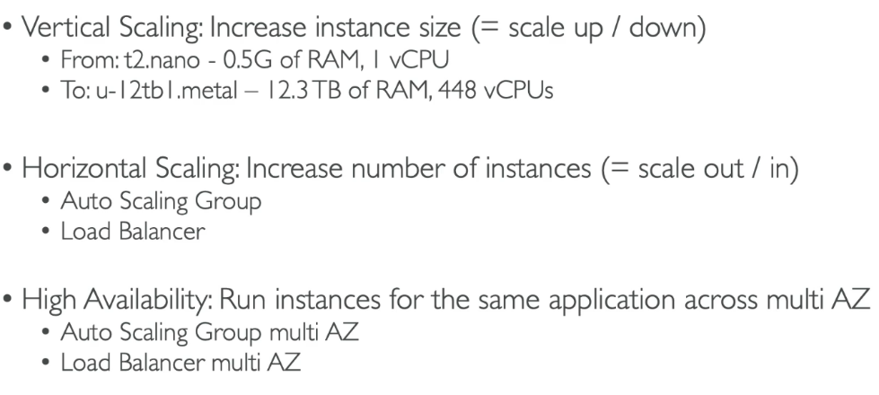

**Load Balancing**

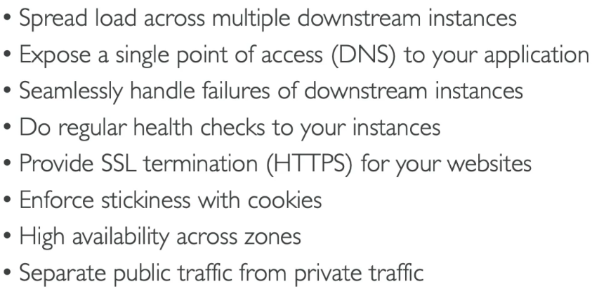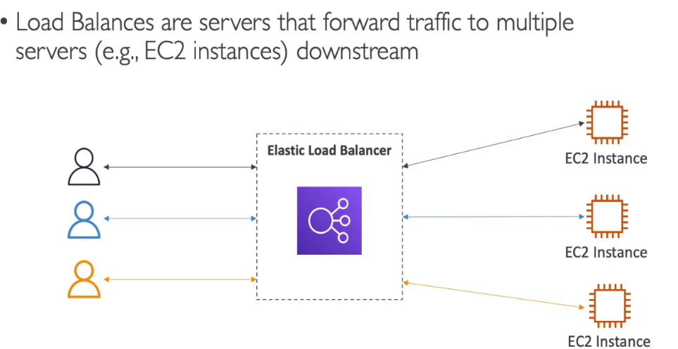In AWS, **load balancing** is the process of distributing incoming network traffic across multiple resources, such as EC2 instances, to ensure no single resource is overwhelmed, improving performance, availability, and fault tolerance.

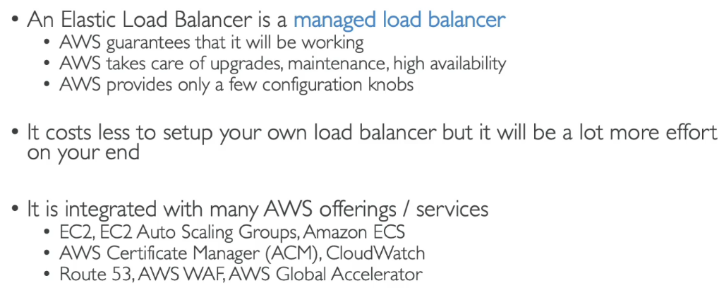**Why use an Elastic Load Balancer**

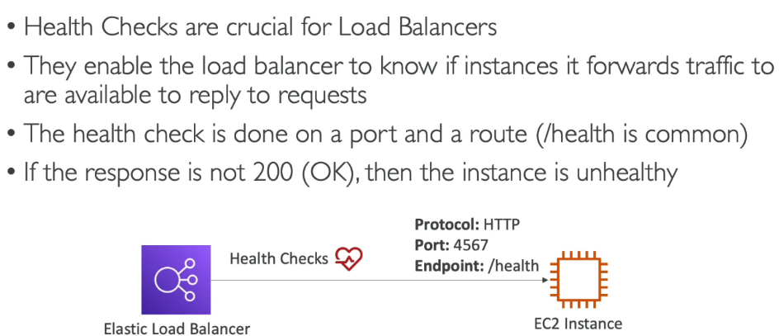**Health Check**

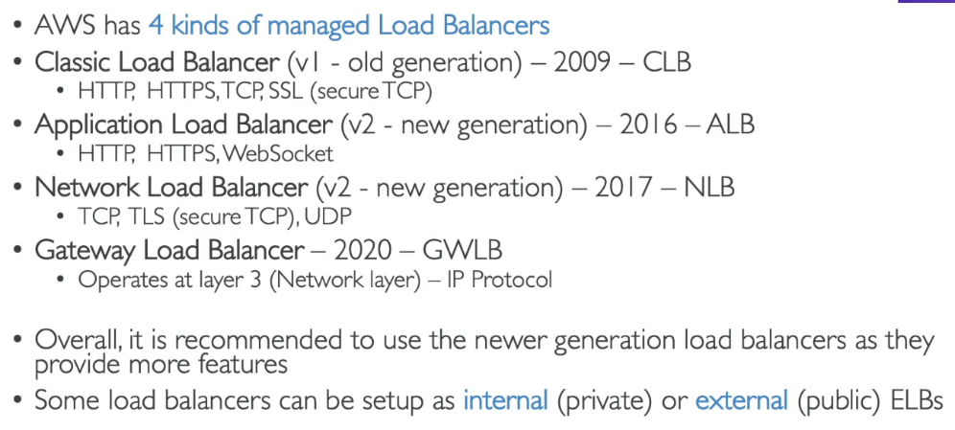**Types of load balancer on AWS**

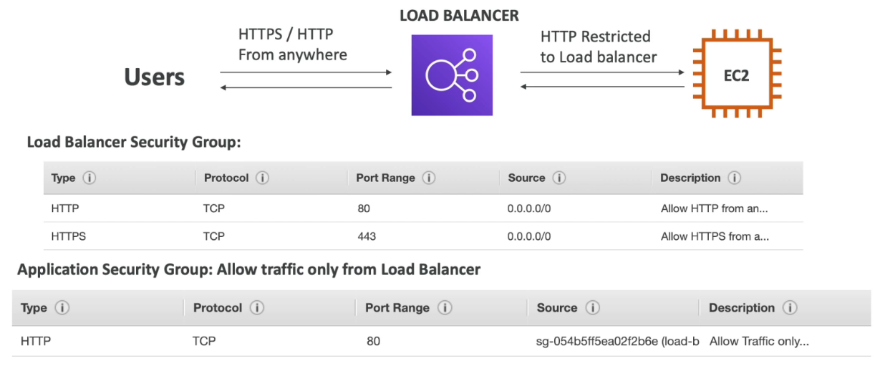**Load Balancer Security Group**

The load balancer should allow traffic from anywhere so the ip will be 0.0.0.0/0 but the instance connected to that load balancer should allow traffic only from the load balancer attached to it. That’s what is is shown in the fig above

**Types**

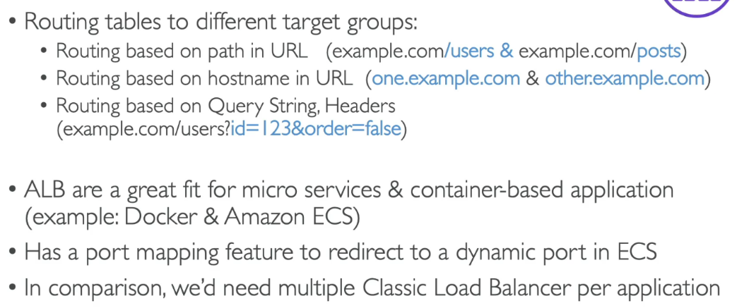**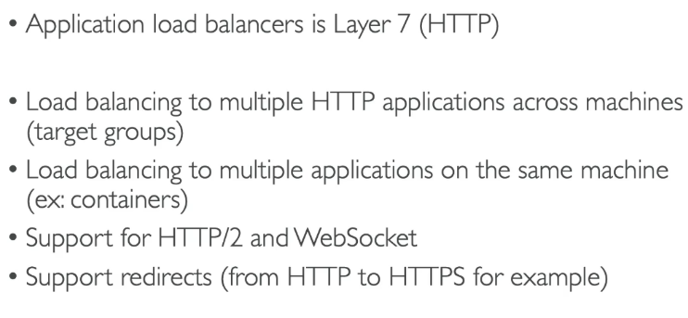Application load balancer**

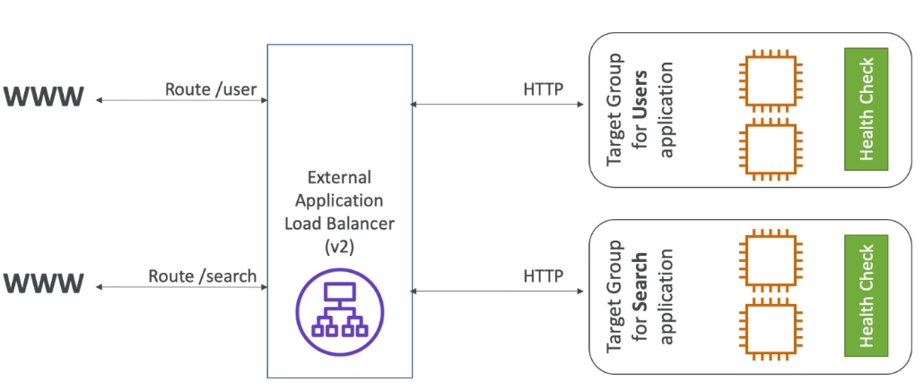**HTTP Based Traffic**

**Target Group**

A Target Group in an Application Load Balancer (ALB) is a group of backend servers or resources (like EC2 instances, containers, or Lambda functions) that the ALB sends incoming traffic to. Imagine you have a food delivery app:

* **Target Group 1**: Handles user login (e.g., Lambda functions for authentication).
* **Target Group 2**: Handles order processing (e.g., EC2 instances).
* 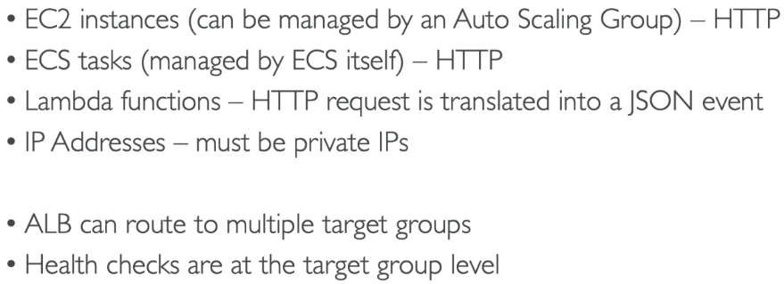The ALB sends login requests to **Target Group 1** and order requests to **Target Group 2**.

**Query String/Parameter Routing**

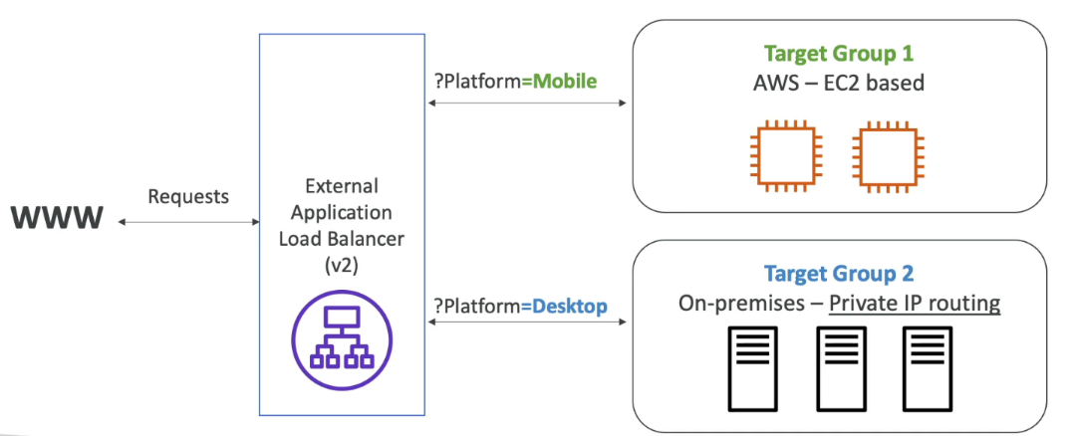**Query string/parameters routing** in an **Application Load Balancer (ALB)** allows you to route requests based on the query string or parameters in the URL. This is useful for directing traffic to different backend servers based on the specific details included in the URL query.

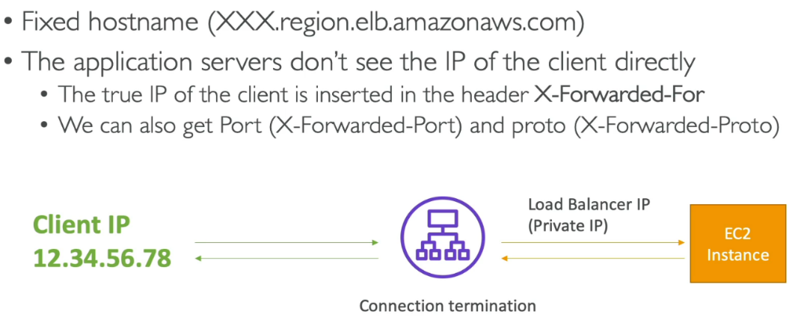**Good to know**

**Network Load Balancer**

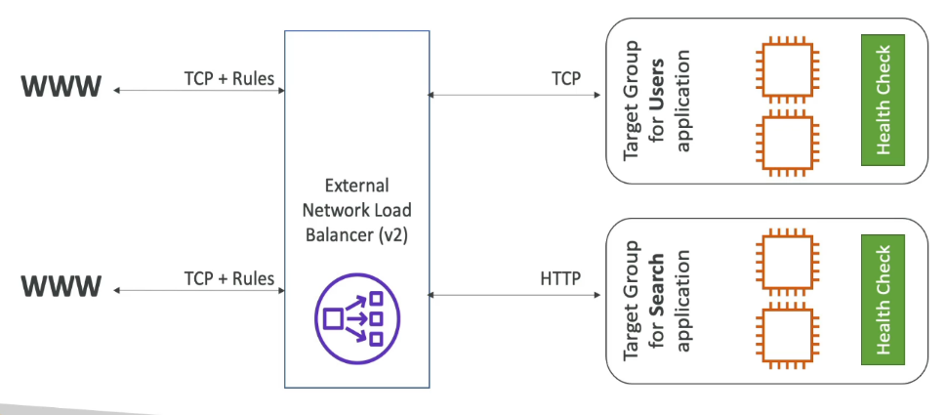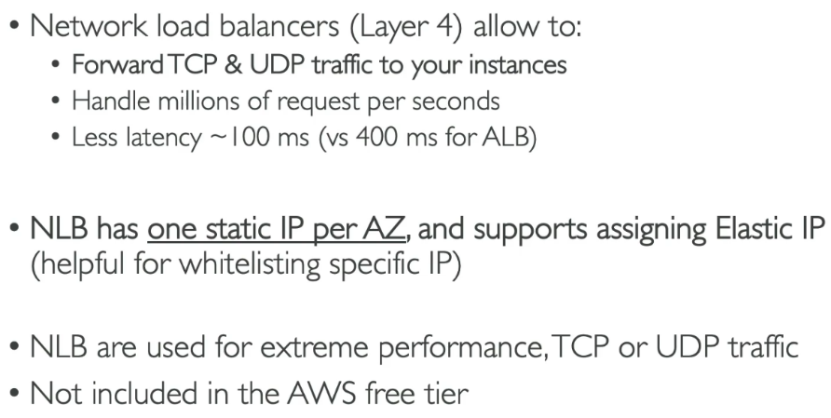A **Network Load Balancer (NLB)** in AWS operates at the **transport layer (Layer 4)** of the OSI model and is designed to handle high-performance, low-latency traffic with millions of requests per second.

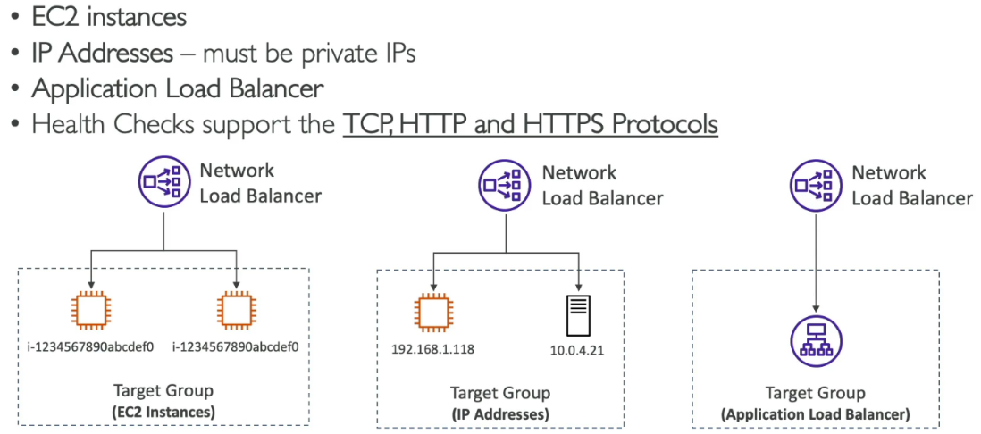**Target Groups**

An **NLB** can send traffic to an **ALB** when you need features like static IPs, handling different types of traffic (like TCP and HTTP), or combining the speed of NLB with the advanced routing and security options of ALB.

Gateway Load Balancer

A **Gateway Load Balancer (GWLB)** is a fully managed load balancer that enables you to deploy and scale virtual appliances, such as firewalls. It operates at the **network layer (Layer 3)** and is designed to route traffic to your virtual appliances while maintaining high throughput, low latency, and traffic inspection capabilities.

In AWS, a **virtual appliance** is a pre-configured software solution that provides specific network or security functions within your cloud environment. These are deployed on Amazon EC2 instances or integrated with AWS services. Examples include virtual firewalls (e.g., Palo Alto Networks or Fortinet), intrusion detection and prevention systems (e.g., Snort or Suricata), and VPN gateways.

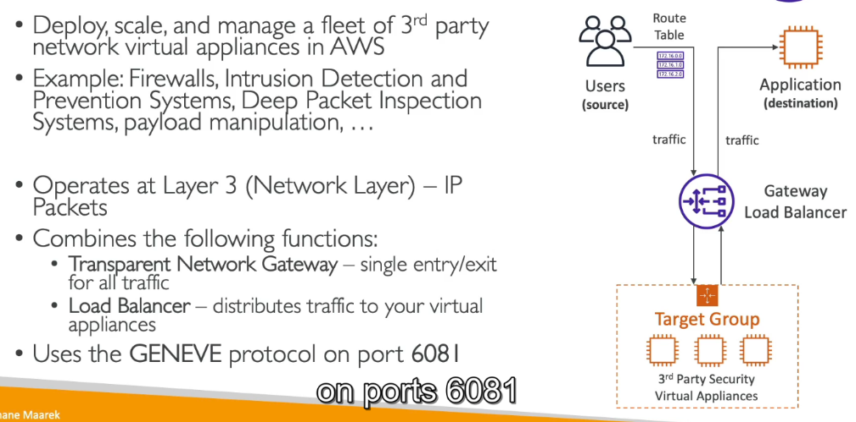

A **Gateway Load Balancer (GWLB)** works at **Layer 3 (the Network Layer)** of the OSI model, which means it focuses on routing traffic based on IP addresses. It doesn’t look into the content of the traffic (like web requests or files) but simply forwards data packets to the right destination.

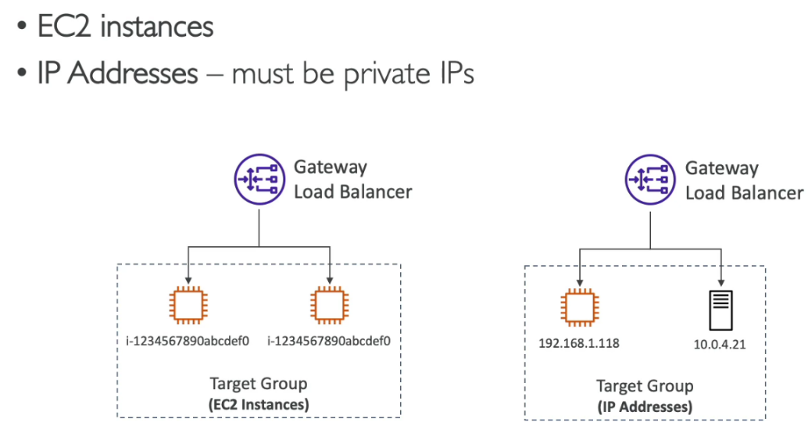**Target Groups**

**Sticky Sessions (Session Affinity)**

Sticky sessions, also known as **session affinity**, are a feature in load balancers that ensures all requests from a particular client are routed to the same backend server for the duration of their session. This is useful for applications that store session-specific data (like user authentication or shopping cart information) on individual servers rather than in a centralized database.

The load balancer inserts a cookie into the client’s response to identify the specific server, ensuring subsequent requests go to that same server.

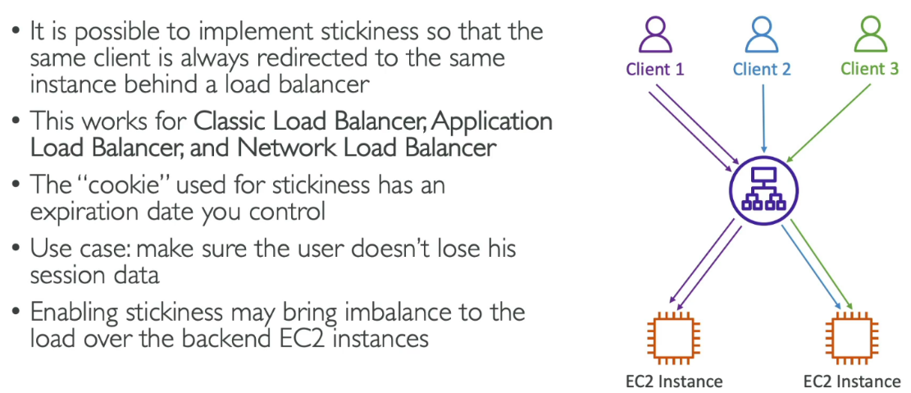**Cookie Name**

There are two type of cookies:

**Application-based cookies**

They are managed by your application, allowing the load balancer to use existing session cookies (e.g., SESSION_ID) to route traffic to the same backend, giving the application full control over cookie content and expiration. This is ideal for apps already using custom session cookies.

**Duration-based Cookies**

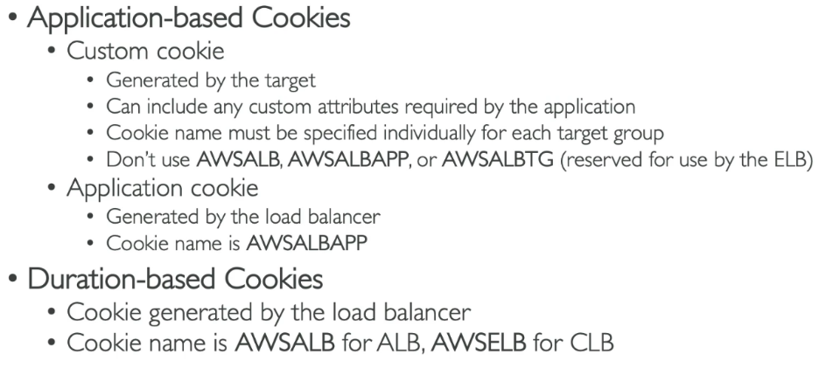In contrast, **duration-based cookies** are automatically created by the load balancer (e.g., AWSALB or AWSELB) and bind clients to a backend server for a configurable duration, making them a simple option for applications without their own session management.

**Cross-Zone Load Balancing**

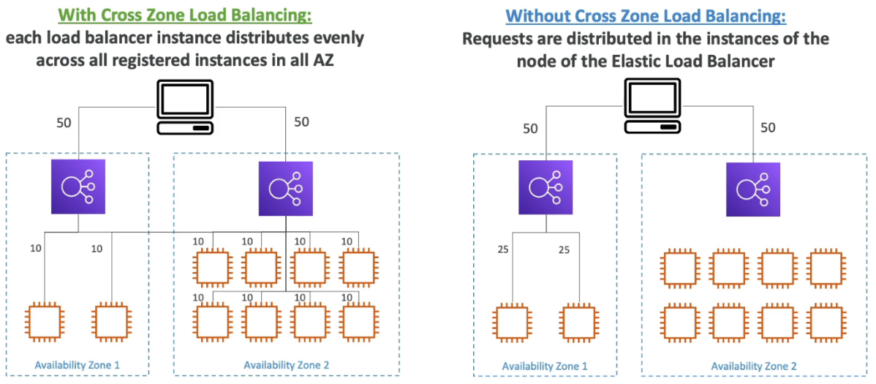**Cross-zone load balancing** makes sure traffic is evenly distributed across all backend servers, no matter which availability zone (AZ) they are in. Without it, servers in one AZ might get more traffic than others, leading to uneven loads. When enabled, the load balancer can send traffic to any healthy server, even if it's in a different AZ, improving performance and resource use.

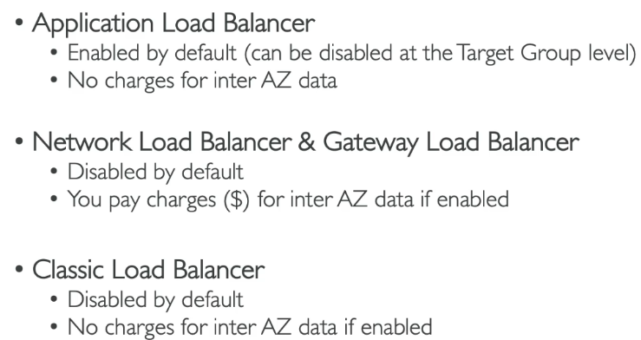

**SSL/TLS – Basics**

In AWS, **SSL/TLS** (Secure Sockets Layer/Transport Layer Security) ensures secure communication between clients and servers by encrypting data in transit. AWS provides **AWS Certificate Manager (ACM)** for managing SSL/TLS certificates easily, including issuing free certificates for use with services like **Elastic Load Balancers (ALB/NLB)**, **CloudFront**, and **API Gateway**.

**Relation among TLS/SSL SSH HTTPS KMS**

Imagine you’re sending a confidential letter (data) to a friend (server). You put the letter in an envelope (SSL/TLS), write the recipient’s address (HTTPS for websites), and use a secure courier (SSH) to deliver the letter to your friend’s house. To protect your letter, you store the key to the envelope in a safe (KMS), ensuring only the recipient can open it with the correct key.

In short:

* SSL/TLS = Secure encryption during transit.
* HTTPS = Secure website communication using SSL/TLS.
* SSH = Secure remote server access.
* 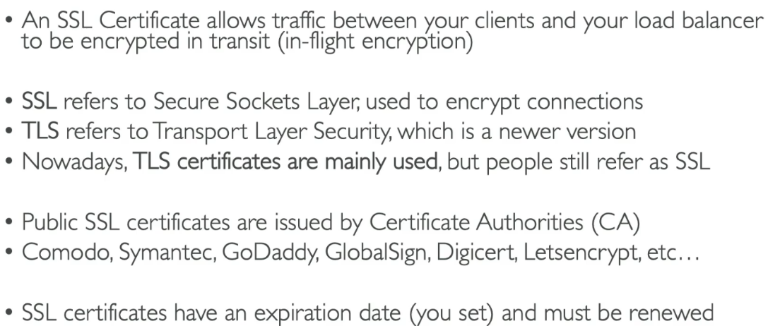KMS = Manages the encryption keys used by SSL/TLS and SSH to keep everything secure.

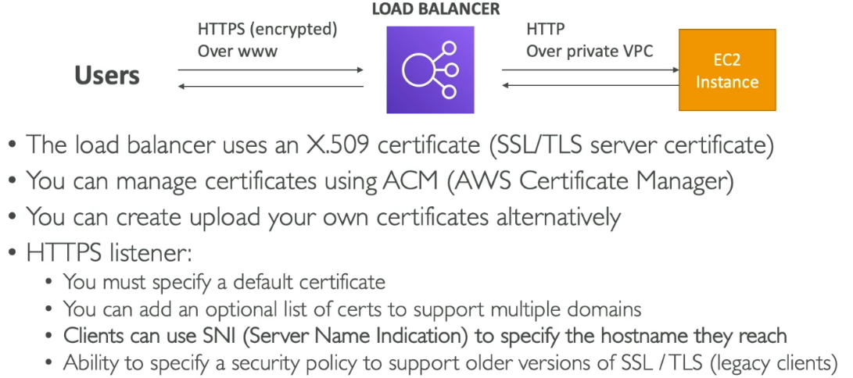

**SNI – Server Name Identification**

**SNI (Server Name Indication)** is an extension to the **SSL/TLS** protocol that allows a client (like a web browser) to indicate the hostname it is attempting to connect to during the SSL/TLS handshake. This enables a single server to host multiple SSL/TLS certificates for different domains, allowing it to serve HTTPS traffic for several websites using different domain names, all on the same IP address.

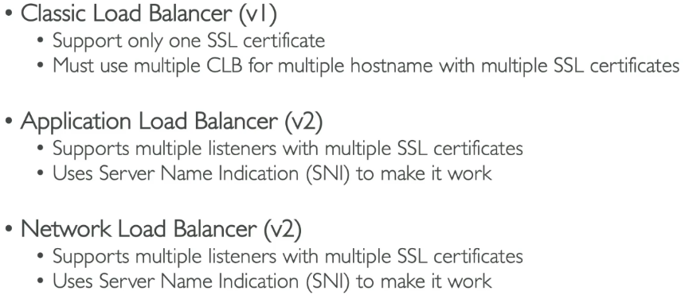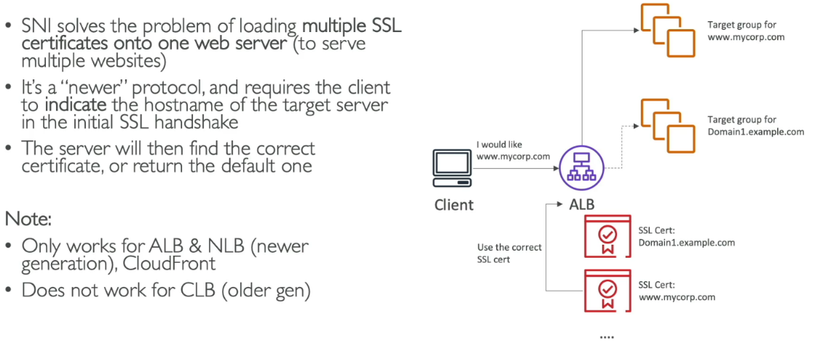Imagine you run a **hotel** (server) with many rooms (websites), and each room has its own **security system** (SSL/TLS certificate) to ensure guests' safety. Now, instead of giving each guest (client) a separate key (IP address) to access their room, you give them a **keycard** (SNI) that tells the security system which room they are going to.